CONCEPTUAL DESIGN OF REST-BASED GEOSPATIAL WEB APPLICATION

RIFQI ALFADHILLAH SENTOSA

July, 2024

SUPERVISORS:

dr. J.M. Morales Guarin

dr.ir. R.A. de By



CONCEPTUAL DESIGN OF REST-BASED GEOSPATIAL WEB APPLICATION

Rifqi ALFADHILLAH SENTOSA

Enschede, The Netherlands, July, 2024

Thesis submitted to the Faculty of Geo-Information Science and Earth Observation of the University of Twente in partial fulfilment of the requirements for the degree of Master of Science in Geo-information Science and Earth Observation.

Specialization: Geoinformatics

SUPERVISORS:

dr. J.M. Morales Guarin

dr.ir. R.A. de By

THESIS ASSESSMENT BOARD:

[Title, Initials, Name (Chair)]

[Title, Initials, Name (External Examiner, Name Institute)]

etc

Disclaimer

This document describes work undertaken as part of a programme of study at the Faculty of Geo-Information Science and Earth Observation of the University of Twente. All views and opinions expressed therein remain the sole responsibility of the author, and do not necessarily represent those of the Faculty.

Abstract

Type the text here.

Acknowledgements

Type the text here.

Table of contents

Contents

1. Research Introduction 1

1.1. Introduction 1

1.1.1. Research Objectives 2

1.1.2. Research Questions 2

1.1.3. Research Outline 3

2. Literature Review 5

2.1. Model Driven Architecture (MDA) 5

2.1.1. Core Concepts and Components of MDA 5

2.1.2. Unified Modelling Language (UML) 7

2.2. Web Application Development 7

2.2.1. Current Practice and Trends in Web Application Development 8

2.2.2. Model Driven Development (MDD) 8

2.3. Representational State Transfer (REST) Architectural Style 9

2.4. OGC API Standards 10

3. Research Method 13

3.1. Domain Modeling 13

3.2. Requirement Analysis 13

3.3. UML Profile Development 14

3.4. MDA Demonstration 15

3.4.1. PIM creation 15

3.4.2. PIM to PSM transformation 15

3.4.3. PSM to Code transformation 16

4. Result 17

4.1. Domain Modeling 17

4.1.1. Geospatial Web Application Observation 18

4.1.2. Common Functions Identification 22

4.2. Requirement Analysis 24

4.2.1. Search Location 24

4.2.2. Measure Distance 25

4.2.3. Select Basemap Layer 26

4.3. UML Profile Development 26

4.3.1. Conceptual Model 27

4.3.2. PIM Profile Development 31

4.3.3. PSM Profile Development 41

4.4. MDA Demonstration (not yet structured) 54

4.4.1. PIM Instantiation (not yet structured) 54

4.4.2. PIM to PSM Transformation Development (not yet structured) 54

4.4.3. XXXXXXXXXXX 54

5. Discussion and Recommendation 55

5.1. Title section 55

5.1.1. Title sub-section 55

List of figures

List of tables

# Research Introduction

## Introduction

A Web application is software that depends on or uses the World Wide Web infrastructure to execute properly (Gellersen & Gaedke, 1999). A sophistication in this is geospatial functionality that leverages geospatial information, thanks to global access of location-based information and services (Veenendaal, 2015). A supportive factor in its realization is the recently updated OGC API standard by Open Geospatial Consortium, which advocates the use of resource-oriented REST architecture (OGC, 2023) in geospatial web applications. It aligns with the concept of REST API, one of the most accepted architectural styles in the web. It allows web application specifications to be broken down into independent components, improving the application’s modularity and unlocking future interoperability and the possibility to use diverse formats (Blanc et al., 2022).

Development of geospatial functionality in a web application is not an easy task for GIS and Remote Sensing (RS) practitioners, who are often unfamiliar with web development methods. Software development as a field of engineering, including web application development, is technically complex and requires advanced design skills to develop the application (Barry & Lang, 2003). Traditional software development life cycle (SDLC) concepts like requirement analysis, wireframing, and testing, including methods like agile development and the waterfall model, are a field by itself and requires skills that GIS/RS practitioners often are unfamiliar with.

Various high-level abstraction techniques aim to bridge between domain-based knowledge and software development such as Model-Driven Architecture (MDA) (OMG, 2014), web-based engineering, including UML-based Web Engineering (UWE), Model-Driven Web Engineering (MDWE) and even agile-based Mockup-Driven Development (MockupDD) (Rivero et al., 2012). They all provide possibilities to develop applications but they come with a steep learning curve for the potential non-developer user. To support the sophistications in both implementations of modern geospatial web applications and the available approaches to develop one, high-level conceptual designs of what are required in developing REST-based geospatial web applications become crucial resources to enable a web application development with more approachable nature for non-developer GIS/RS users.

This research aims to define a conceptual design of the modern REST-based geospatial web application and demonstrate the concept by using Model Driven Architecture (MDA) approach. MDA is an approach that helps to understand complex systems by solving the system’s complexity and interdependencies by using models (OMG, 2014). MDA initiative is a well-researched subject, with examples including Elleuch et al. (2007) and Jovanović et al. (2013) who brought Model Driven Engineering, a concept related to the OMG’s MDA initiative, to software architecture and user interface domain; Betari et al. (2018) attempted and modeled the transformation of Computation Independent Model (CIM), the highest level abstraction model in MDA principle; and Meliá et al. (2005) who approaches architecture modelling with MDA’s lingua franca of Unified Modelling Language (UML).

By collecting varying types of existing geospatial web applications and performing domain modelling with added perspective of REST architectural style and OGC API standards to retrieve the requirements, MDA approach is implemented with its abstraction level-based separation of concern to convert the common requirements into stereotypes packaged into applicable UML profile. The developed profile will be transformed into MDA demonstration, where the profile will be used in creating an example of user-defined Platform Independent Model (PIM) of a connected data and visualization concepts, then transformed from one abstraction level to Platform Specific Models (PSM) which led into computer code of a REST-based geospatial web application.

The expected result of this research will add value to the state-of-the-art in several ways. The developed UML profile will be a well-provided concept design for non-developer, GIS/RS users and practitioners to generate REST-based geospatial web applications according to their specific requirements. This allows geospatial web application development to be performed without the necessity of understanding most of the niche terminologies contained within the web application development. This way, individuals can seamlessly integrate geospatial property in their web applications with less time, efforts, and even the code lines itself. At the same time, the UML profile and the proposed approach in regard to coming up with the conceptualized common requirements, developing the stereotypes and profiles, and demonstrating MDA modelling and transformations will result into a well-documented guide for developers to continue developing the approach. Continued development of this model driven approach will widen the possibility, flexibility, and sophistication of what type of REST-based geospatial web applications that can be developed.

### Research Objectives

The main objective of this research is to develop UML profile of stereotypes based on common requirements for REST-based geospatial web application development using Model Driven Architecture (MDA) method.

Based on the main objective, there are three sub-objectives to this research:

1. To conceptualize common components that can be represented as functional requirements of REST-based geospatial web application.
2. To develop UML stereotypes and profiles that represent the common requirements of REST-based geospatial web applications.
3. To demonstrate how the proposed UML profiles are being used in developing REST-based geospatial web application using MDA approach.

### Research Questions

Related to the first sub-objective:

1. What are the common functions and components found in geospatial web applications?
2. What are the functional requirements observed from selected common functions of geospatial web applications?
3. What are the potential classes, attributes, operations, and relationships found from conceptualizing the functional requirements?

Related to the second sub-objective:

1. What are the proposed UML stereotypes for Platform Independent Model (PIM) abstraction level?
2. What are the proposed UML stereotypes for Platform Specific Model (PSM) abstraction level?
3. How do the proposed UML stereotypes be developed into UML profiles?

Related to the third sub-objective:

1. How does the proposed UML profiles support the development of the Platform Specific Model (PIM); and what are the characteristics of the developed PIM?
2. What are the transformation rules to generate Platform Specific Models (PSM) from the PIM; and what are the characteristics of the developed PSMs?
3. What are the transformation rules to generate the web application code from the PSM; and what are the characteristics of the generated code?

### Research Outline

*Opening paragraph*

*Chapter 1 – Introduction*

*Chapter 2 – Literature review*

*Chapter 3 – Methodology*

*Chapter 4 – Research Result*

*Chapter 5 - Discussion*

# Literature Review

The objective of this chapter is to provide an overview of the current and past literatures regarding the main concepts of the research. Firstly, the concept of Model Driven Architecture (MDA) approach is introduced as the main lens of the research. Afterward, the subject on web application development is discussed. This section also brings Model Driven Development (MDD) where web application development intersects with the concept of MDA as the main lens of the research.

The literature review continues deeper into the geospatial web application niche where REST architecture and OGC API standards are introduced. REST architecture is one of the widely used architectural style in current times, especially in web environment. At last, its relation to MDA is discussed to find how REST architecture aligns with the principle of MDA and vice versa which will reflect on the result of this research.

Lastly, OGC API standards is introduced as the last concept. It is the recent sophistication in geospatial web application domain that allows geospatial web application development to follow modern trends and inspire this research to be undertaken. In the end, its relation to MDA is explored to see how both concepts can be implemented to each other.

## Model Driven Architecture (MDA)

Model Driven Architecture (MDA) is a software designing approach to derive value and to provide guidelines for designing specifications of a software using models (OMG, 2014). It is a well-documented and guided family of standards maintained by Object Management Group (OMG) that has been a center of research and being implemented in various domains such as IT, healthcare, manufacturing, and government.

MDA promotes abstraction of complex details using high-level model to provide a structured representation of application design approach, making it easier for developer to build and understand a complex system. It highlights the use of detailed and automatically transformable models that generate executable codes of specified type of systems (Xiao & Greer, 2009). Due to its convenience and popularity, MDA has become one of the most used approaches in model-oriented software and application development.

### Core Concepts and Components of MDA

MDA contains a package of standards that cover several concerns: the abstraction models using various options of modelling languages, the model transformations, the documentations, and the model executions (OMG, 2014). MDA introduces three types of abstraction levels in modelling different viewpoints: Computer Independent Model (CIM) for expressing the working logic of an application, Platform Independent Model (PIM) for describing the information system without being tied to any platform, and lastly Platform Specific Model (PSM) for modelling the information system with more specificity using certain platforms. The models will be transformed from one level to another using defined transformation rules, with each level of transformation promotes various amount of automation.

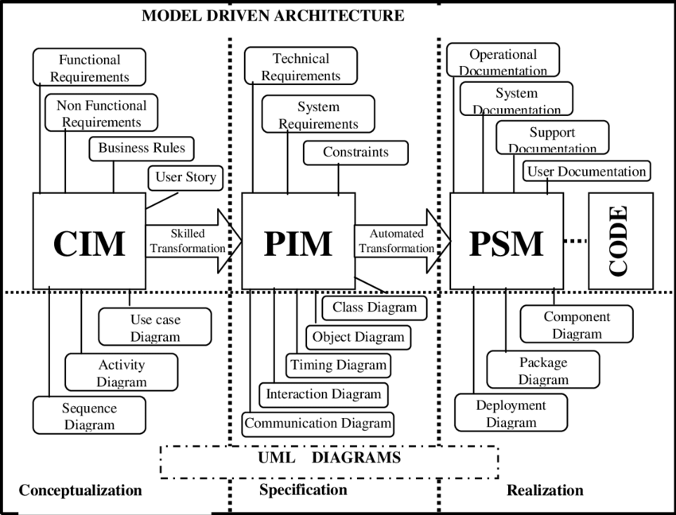

The abstraction models as core concepts of Model Driven Architecture (Singh & Sood, 2010)

Computation Independent Models (CIM) describe systems from a high-level perspective, focusing on the environment and requirements without technical details. It is commonly being referred as business model and domain model. Compared to the other abstraction models in MDA, CIM is seen as model used for analysis that helps to meet business and user requirements (Singh & Sood, 2010).

Platform Independent Models (PIM) emphasize the creation of models in which it specifications and functionalities are separated from implementations on any specific platforms. This level of abstraction disregards any kind of operating systems and programming languages (Betari et al., 2018). The use of PIM promotes technical flexibility and easier adaptation to different technologies in later abstraction (Ameller et al., 2015). PIM is seen as model used for designing the concepts of the domain (Singh & Sood, 2010).

Platform Specific Models (PSM) adopts platform-specific details to the PIM, adapting the system to a particular technological context. It details the implementation of a system including specific technologies, platforms, and frameworks, bridging the gap between the design and the actual code. PSM is seen as model used for implementation (Singh & Sood, 2010).

Model transformation is one of the main themes points of model-driven approach. By using selected model transformation, a model can be automatically transformed into another model (Thomas, 2004). In MDA context of abstraction models, the transformations define the way PIM can be transformed into PSM with the rules provided by the developer of the model transformation (OMG, 2014). MDA standardized several modelling and transformation languages from which model developers can choose from such as Design Specific Language (DSL), Query/View/Transformation (QVT), and Unified Modeling Language (UML).

In this thesis, the abstraction levels involved in the research start from PIM to PSM to direct the focus on functionality rather than higher level context of having geospatial web application, where the technical-focused level caters the target users of the research that will be elaborated more in Section XXX.

### Unified Modelling Language (UML)

UML is one of modelling languages developed by Object Management Group (OMG) that refers to the graphical models that represent properties of an object-oriented design (Duke et al., 1997). It is considered as lingua franca in software engineering (Wimmer et al., 2006). Various UML types are available for use depending on specific user goals, such as class diagram, use case diagram, and activity diagram (Shcherban et al., 2021).

UML is a widely accepted modelling language in software and web application development industry. It also adopts best practices and aligns w ell with most development frameworks in the industry, even compatible with handling RESTful web service designs (Rauf et al., 2010). The clear visual abstractions of UML, widespread adoption, and being developed and standardized by the same institution as Model Driven Architecture (MDA) adds UML dependability factor as a modeling language.

There are two separations of UML diagram types: structural and behavioural. Structural diagrams model elements in a domain to be static and true at a specific point in time (OMG, 2017) which include diagrams such as class diagram, deployment diagram, profile diagram, and component diagram (Ma & Chao, 2020). Behavioural diagram model domain elements as they change over time (OMG, 2017) which includes diagrams such as use case diagram, activity diagram, and sequence diagram (Ma & Chao, 2020). In this research, class diagram and profile diagram are heavily used alongside with the concept of UML stereotype that relates to the latter.

UML class diagram is a structural diagram that helps in designing and illustrating instances of classes in a system and relationships inside it (Gosala et al., 2021). It is commonly and heavily used as tool to model software components in a development, especially with its close relation with Object-Oriented paradigm. A class diagram typically consists of attributes (data member of the class), operations (behaviors or functions the class can perform), and relationships (how classes are connected or interact with each other) which are designed to represent elements of a system or domain.

UML profile is an extension mechanism of generic UML concepts to cater specific domain by using predefined set of stereotypes, tagged values, and constraints (Giubergia et al., 2014). Stereotype is the core of the UML profile in extending UML vocabularies, indicated as <<stereotype>> in a profile diagram and has same behavior as a UML class. While it is prohibited to modify the standardized UML and all concepts that are contained in it, this extension mechanism allows the existing UML metaclasses to be used in modeling domain-based problems without changing the original UML vocabularies.

## Web Application Development

Web application development is the action to code or program to create applications accessed through a web browser. Started as an initiative of a small number of researchers in sharing static contents, web has been intertwined with many aspects of the world (Peña-Ortiz et al., 2013) and web applications significantly responsible to that claim. The development of web applications contains many responsibilities, including the process of design, build, and maintenance. Web applications involve two concepts of technologies: frontend for visualization and user interactions; and backend for data processing and retention (Pop & Altar, 2014).

Static web applications present contents to client machine without any server-side processing, which gives faster load times but limited interactivity for the user. In contrast, dynamic web applications can provide and update contents on the fly to respond with user interactions and defined web application logics, which gives customized experience to users but may result to relatively heavier performances. Nevertheless, web applications have important place in the current world as they unlocked global accesses to many aspects of life.

### Current Practice and Trends in Web Application Development

The development of web applications has been closely mirroring those of software development methodologies. Web Development Life Cycle (WDLC) (Kamatchi et al., 2013) follows Software Development Life Cycle (SDLC) techniques to in laying down the typical steps that developer teams go through in developing a web application: identifying website objectives, gathering requirements, perform the design process, test the application through multiple levels, deploy, and do maintenance.

In current industry, several development methodologies have been implemented. Waterfall model is introduced by Royce (1970) as sequence-based development process to follow through like a consecutive list of tasks to be performed to build a software, allowing straightforward ways in collecting requirement and managing team resources at the cost of low flexibility and limited end-user involvement. Agile methodology, a set of iterative and incremental approaches with high adaptability, involves sprints where short iterations are implemented to rapidly deploy parts of software to be tested. The family of Agile approaches such as Scrum and Kanban give the advantages of flexibility, collaboration, and iteration of developing software and web applications while facing challenges in documentation, high dependency to customer collaboration, and requirements for experienced developers to implement (Hossain, 2023).

For the current trends in different levels of the development, several concepts are also found to be common in software development and engineering. Design patterns attempt to apply reusable solutions to common problems in software development (Jiang & Mu, 2011) where patterns like Model-View-Controller (MVC) architectural pattern and Observer pattern are applied to make software development more structured. Lastly, popular frameworks such as React and Angular provide tools and libraries of best practices in building software and applications to enhance programming efficiency and maintainability.

### Model Driven Development (MDD)

Modeling is one of core tasks in software development, and Model Driven Engineering (MDE) became popular among developers. It leverages the concept of using models in representing applications in different levels of abstraction, and using commonly automatic, top-down model transformations to define the specificity of the previous model to other models, become ultimately deliver the final application (Rivero et al., 2012). This approach is known by several terminologies laid down by Whittle et al. (2014) including Model Driven Engineering (MDE) as the superset of MDD and Model Driven Architecture (MDA) as one of MDD instances that comply with OMG standards. Despite the interchangeable semantics of the approach, the general model driven concept is the same, and it has been proven to be beneficial to software and application development as it is a very powerful tool approach to document software architecture and eventually perform code generation, especially in domain-based companies and projects where new developments can conveniently be performed thanks to the abstraction modeling MDD proposes (Whittle et al., 2014).

Multiple software and web engineering methods apply MDD principles. Distante et al., (2007) classified this kind of web application design methods into two categories: the conceptual design-focused ones that prioritize on showing what is required for the application to perform, where approaches such as Ubiquitous Web Application (UWA) and Object-Oriented Web Solutions (OOWS) are fell into; and the logical design-focused that prioritize on showing how to implement those requirements, where a proposition from Conallen (1999) on building web application with UML is fell into. Anything in between is considered hybrid methodologies that covers both logical and conceptual designs, which includes popular methods like UML-based Web Engineering (UWE) and Web Modeling Language (WebML).

It is showcased above that MDA has been intensely studied in web application development subject and being within a larger category of the Model Driven Development. This thesis research will implement MDA in coming up with the conceptual design of developing REST-based geospatial web applications. UML as part of MDA standardized concepts is the core tool to capture the requirements that should exist in such applications. Most of the existing MDA methodologies in web application development arguably can achieve the objective of demonstrating this research. However, it is important to address that the mostly suitable target of these methods are most likely developers with enough understanding of UML and MDA to proceed, whereas this research requires to provide flatter learning curve for non-developer target users.

## Representational State Transfer (REST) Architectural Style

REST (Representational State Transfer) is an architectural style derived from the aggregation of several architectural style with web constraints, resulting in a style that are suitable for network-based applications (Fielding et al., 2017). It is a widely adopted approach for remote programming resources to benefit from remote APIs or services (Rodríguez et al., 2016).

The popularity comes from its core paradigm that it is a web service design that treat everything as a resource and has relatively fewer standards-compliances compared to its popular predecessor Simple Object Access Protocol (SOAP) web services, an XML-restricted protocol that has more processing times and heavier payload than REST (Malik & Kim, 2017). The governing principle of REST architectural style is based on HTTP protocol which has been fitted to web environment. The programming interfaces that follow REST architectural style are names as REST APIs.

RESTful design promotes scalability and interoperability of web services and APIs by abiding to its core principles, as laid down by Rodríguez et al., (2016):

* Resource addressability: Resources should be uniquely identified using Uniform Resource Identifier (URI).
* Resource representation: The internal structure and state of resources are kept hidden from the clients/users as they are represented only by the resource representations, XML and JSON format being the common formats, in help of HTTP protocol to manage the representations.
* Uniform interface: Resources are handled using standardized methods of HTTP protocol.
* Statelessness: Client request to the API should contain all information required to be processed, so that the server does not keep any interaction state.
* Hypermedia as the engine of state: Links between resources allow users to understand the relationships and the interaction state.

To implement REST architectural style to MDA-based web application development, it can be addressed that multiple principles between the two concepts are aligned. UML class diagram with its OO-approach is seen as fitting tool to represent REST-based web application (or to support the development of one) with its resource-based principle, where every resource can be represented as one individual class with its own attributes and possible associations and operations to apply to. REST as architectural style also capable to assume the separation of platform independence as a concept and later become technology-specific during the development of web applications.

REST architectural style also reinforces separation between server and client in an instance of web application, which also where MDA can give value with its array of options to represent static and behavioral parts of the web application system. UML-MVC model is an acknowledged approach on how both separation of concerns in applying standardized UML diagrams into MVC design pattern of web applications, which becomes a good example on how the concept of separation of concern found in both MDA and REST architectural style applies in web application development. The UML-MVC approach leverages multiple UML capabilities, namely class diagram for Model and View (combined with Controller) aspects of MVC, associations between classes, and UML sequence diagram for describing the interaction between the components and the navigation steps between View and Model classes (Distante et al., 2007).

## OGC API Standards

OGC API standards is a recently updated geospatial standards by Open Geospatial Consortium (OGC) that allows modular development for geospatial services and systems using resource-based oriented principle (OGC, n.d.-b). Before this, the consortium was focused on maintaining OGC Web Services (OWS) since it was designed in the early 2000. It includes older version of geospatial standards such as Web Map Service (WMS) and Web Feature Service (WFS) that implement action-based Remote Procedure Call (RPC) architectural style which was indeed the state of the art during its time (OGC, n.d.-b).

The latest version of standards is the newest initiative from OGC to facilitate the adoption of the latest OpenAPI Specifications 3.0 (OAS), a programming language-agnostic described standard for HTTP API, the protocol that bases REST architectural style. This recent innovation is seen as major initiative from OGC to follow current trend in web application development and the enforcement of its family of standards toward geospatial web application will be beneficial in terms of future interoperability with modern tools, especially in promoting geospatial data integration in modern web technologies including web applications (Blanc et al., 2022).

A family of standards were introduced since 2016 such as OGC API Features, OGC API Tiles, and SensorThings API which have been supporting the use of geospatial information to follow the more sophisticated web technologies. The new family of standards adheres RESTful principle that is more lightweight and flexible than its predecessor standards. Based on its status, the standards can be categorized into two categories: Approved Standards and the ones that are not yet approved.

According to OGC API official website page (OGC, n.d.-a), the currently OGC API Approved Standards as of June 2024 are as follow:

* OGC API – Features

The standard for handling “things in the real world that are of interest” (OGC, n.d.-d)

* OGC API – Common

The standard for implementing Web API that confirms to OGC API Standards (OGC, n.d.-b)

* OGC API – Tiles

The standard for implementing Web API that support the retrieval of several types of tiled geospatial information, such as map tiles and vector tiles (OGC, n.d.-h)

* OGC API – Processes

The standard for executable processes a client can call via Web API (OGC, n.d.-f)

* OGC API – EDR

The standard that provides interfaces to access spatiotemporal data resource and perform spatial queries (OGC, n.d.-c)

Several mentionable OGC API Standards that has not yet gotten approval status are as follow:

* OGC API – Maps

The standard for requesting maps through Web API (OGC, n.d.-e)

* OGC API – Records

The standard for handling metadata of resources (OGC, n.d.-g)

OGC API Standards attempts to enforce standardized way to present and manage geospatial data on the web, including in geospatial web applications context. MDA principle of separating the concerns in different level of abstractions have been shown to be useful in modelling domain-specific system including web development with its abundant choices of methods such as UWE, OOWS, and WebML. Therefore, by recognizing that OGC API Standards provide geospatial domain-based solutions for API designer to work with geospatial information on the web, developing those solutions within MDA capabilities is possible.

By using MDA approach in providing and using geospatial data on the web compliant to the OGC API Standards, users can benefit from the MDA’s level of abstractions. One might capture a geospatial data-related requirements or problems as a Computation Independent Model (CIM), create the logical model in Platform Independent Model (PIM) level and afterwards transform PIM into technology-specific implementation of OGC API Standard compliant geospatial web application.

# Research Method

The most important part of this research is to develop a methodology of MDA implementation in developing an example of REST-based geospatial web application, as well as to provide resources and documentation to ensure the developed method is reproducible. The foundation of the methodology lies on

Opening paragraph.

* The purpose of the research
  + The most important part of this research is developing a methodology …
  + The foundation of the methodology lies on …
* The purpose of this section

Figure: flowchart of research methodology

## Domain Modelling

Domain model is a model that captures varying common requirements of a domain (Wang, 2016). It is a common approach that is familiarly used in software development industry. The core of domain modelling lies in the attempt to understand concepts and relationship in a domain and to create representations that explains them. It might involves defining the scope of the subject, identifying the key concepts and relationships, and create the representative model. The purpose is to get the full understanding to navigate through the subject.

In this research, domain modelling is subjected to the domain of geospatial web application development. The purpose of this step is to capture the common functions that commonly found in geospatial web applications by observing the interfaces of several modern geospatial web applications. The main reason for this implementation-based approach is to assume practical, user-centred perspective. By performing the user-perspective observation, this research attempts to consider the actual user experience in observing what geospatial web application have decided to implement.

This domain modelling step is crucial for collecting all possible concepts, attributes, and relationships to be represented in the modelling step. The expected result of this step in this research are a list of common functions found in observed geospatial web applications that will be continued to be analysed in the later requirement analysis step.

Six (6) modern geospatial web applications are observed to capture their presented functions. As respectively detailed later for each application in the list, the core considerations for which geospatial web applications to be observed are the variety in use cases, data sources and types, license type (open source or proprietary), and the geographic extent (global or local data). These considerations are part of attempt to observe as many varieties of functions as possible in geospatial web applications.

Figure: list of observed GWAs

Below are the listed geospatial web applications:

* Google Maps is a global-scaled, proprietary web-based mapping service developed by Google. Google Maps serves many purposes including navigation and route, business search, geocoding, street view, and many more. The service uses several types of geospatial data including raster and vector tiles, and vector for user-generated point of interests.
* Open Street Map is a global-scaled, open-source project for providing free and editable geospatial data of the world. The project provides several possible services including navigation and routing, geocoding, and analysis. The service uses several types of geospatial data such as tiles and vectors.
* Earth Explorer is a global-based, proprietary geoportal that provides the service to search and download geospatial data and information of the world Earth Resources Observation and Science (EROS) archives by U.S. Geological Survey (USGS). The service provides satellite imagery data to download with various use cases.
* Samenmeten is a Dutch national-based, open-source citizen science platform maintained by Dutch National Institute for Health and Environment (RIVM) that provide measurements of air quality and noise level for public use. The platform provides visualization of sensor locations and the measurements and API for accessing the measurement data.
* ShadeMap is a global-based, proprietary platform that provides simulation of shadows and displays them on the map. It provides free access to machine learning-based shadow simulation for most of the worlds and the more accurate LiDAR-based simulation for its premium users.
* PDOK Viewer is a Dutch national-based, proprietary platform that displays the open government geo-information datasets of The Netherlands. PDOK geoportal provides access to varieties of data via API using various services such as WMS, WMTS, and WFS.

After observing all the geospatial web applications, the captured functions are then generalized to retrieve a list of common functions found among the geospatial web applications. The purpose of this step is to categorize all functions with similar purpose into one category which lead to a list of common functions to be brought as input for the next step of the research.

## Requirement Analysis

According to IEEE Standard 610 (IEEE, 1990), requirement analysis is “the process of studying user needs to arrive at a definition of system, hardware, or software requirements.” It is an important step to understand and manage what needs to be in a developed software or application. The purpose of this approach is to ensure a software or application to be effectively developed.

In this research, requirement analysis is applied to the common functions resulted from the domain modelling step. The purpose is to retrieve the typical functional requirements between frontend, backend, and data when a user interacts with a function in a geospatial web application. Functional requirement is one of the software requirement types which handle specific functionalities such as calculation, data manipulation, and user interaction in a software or application. In this research step, functional requirements are defined to be the requirements that a common function specifically need for it to be executed properly in a geospatial web application.

Multiple common functions are selected from the common function list for the requirement analysis. The selection process considers each selected function have different type of logics behind them to capture as many functional requirements and related components as possible. Each selected common function is analysed and is then described in natural language for its typical frontend and backend processes behind it. The analysis processes are taken from the perspective of REST architectural style and OGC API standards where they will influence which elements and components that are involved. The expected result of this step is natural language-based descriptions of functional requirements of the selected common functions which will be used in later UML profile development step.

## UML Profile Development

UML profile development or profiling is a mean to extend existing UML concepts to suit a particular subject or domain (Gómez et al., 2019). The concept of UML stereotype is used for this extension approach to constructs UML profile, where the stereotypes can be enriched with attribute values for more extended use. This profiling mechanism is seen as underutilized despite many significant improvements being made on the recent UML version (Selic, 2007). The expected results of this step are UML profiles that will be used to implement instances of PIM and PSM in MDA demonstration.

In this research, UML profile development starts by using the functional requirement descriptions from requirement analysis step as basis to create conceptual model of the requirements. The functional requirement descriptions are interpreted by capturing the nouns and verbs from the description that potentially become UML class, attribute, operation, and association names. Afterwards, the result will be generalized into UML classes with careful choice of semantics. The expected result is a collection of potential UML classes that become the basis for creating the real UML profiles used for building PIM and PSM instances.

The next step is to develop UML profile that will be used to build PIM instance (namely “PIM-Profile” for brevity). The conceptual UML classes from previous sub-step are split based on the technological dependencies, where every UML classes that is interpreted to be independent is used for developing the PIM-Profile. The approach will be to convert the UML classes from the conceptual model into stereotypes with careful choice of semantics for each class and their related elements.

Model-View-Controller (MVC) design pattern is applied in developing the PIM-Profile. MVC is a widely used design patten that adopts the principle of separation of concerns, splitting the data representation (Model), interface (View), and interaction functions (Controller) (Syromiatnikov & Weyns, 2014). This separation principle enables simplified complexity and improved reusability of its parts in a development (Lu et al., 2021).

Figure: MVC design pattern

In this context, MVC pattern helps in splitting the research to categorize the stereotypes in consideration to making the model intuitive and bringing convenience in later transformation steps. This approach separates the stereotypes into three (3) UML profiles that are represented in one UML package diagram, a grouping diagram purposed to encapsulate classes, diagrams, or other packages into a higher-level model. The expected result of this sub-step is a package diagram containing PIM-Profiles with MVC categorization. Figure XXX shows the concept of this approach in visual format.

Figure: PIM-Profile concept

Lastly in this step, similar approaches in developing the PIM-Profile model are used to build PSM-Profile. The conceptual UML classes that are interpreted to have technological dependencies become the basis of this sub-step. Afterwards, for each MVC aspect, a package diagram of UML profiles is created. In this sub-step, package diagrams are created to categorize several technology-relates UML profiles (e.g. profile for PostgreSQL, profile for Leaflet) based on MVC design pattern, where they will be represented in another higher-level package diagram. The expected result of this sub-step is a package diagram containing three package diagrams, where technology-related UML profiles are categorized based on MVC design pattern and contains stereotypes related to that technology. Figure XXX shows the concept of this approach in visual format.

Figure: PSM-Profile concept

## MDA Demonstration

Model Driven Architecture (MDA) is a standardized instance of Model Driven Development (MDD) paradigm which core concept involves taking complex systems into high-level abstraction to generate structured representation of such systems. Object Management Group (OMG) manages sets of standards for implementing MDA in the development of software and applications, such as standards on modelling languages including UML and model transformations.

In this research, MDA is demonstrated to showcase the proof of concept for the developed UML profiles. Stereotypes from PIM-Profiles are used in building an instance of PIM diagram. The diagram is then brought to transformation steps using defined transformation rules and language into PSM diagram that are built upon stereotypes from PSM-Profiles. Lastly, the PSM diagram is taken into code generation step where it is transformed into computer code of a geospatial web application. For each sub-step within the MDA demonstration, different scope and level of details are introduced. Figure XXX shows the walkthrough of the whole step in visual format.

Figure: MDA transformation flowchart

### PIM Instantiation

In this sub-step, an instantiation of Platform Independent Model (PIM) is generated using stereotypes from the developed PIM-Profile diagram. Rules and constrains in using PIM-Profile stereotypes are introduced during the demonstration process for documentation purpose. The documentation is expected to guide users in replicating the approach in creating their own instance of PIM. The expected result of this sub-step includes the demonstration of developing a PIM instance using PIM-Profile stereotypes, the PIM instance itself, and the documentation of the workflow.

### PIM to PSM Transformation

Transformation is one of the central elements of Model Driven Architecture (MDA). Transformation in MDA offers automation in converting one model to another lower-level model using selected transformation language. This is to ensure consistency of the models and improve time efficiency in development (Ledang & Dubois, 2010).

In this sub-step, the developed PIM instance is taken into transformation step to instances of Platform Specific Model (PSM) which are built upon the PSM-Profiles. The expected result of this sub-step includes the demonstration of transforming a PIM instance into PSM, the model transformation process including transformation rules and language used, the PSM instance itself, and the documentation of the workflow.

First, transformation rules are developed and introduced to the process, giving constrains and directions as to what should happen in the transformations. Each transformation rule is also demonstrated to transform the PIM instantiation. One important transformation rule assigned in this research is the use of JavaScript Object Notation (JSON) for the diagram. JSON is a light file format for data exchange that is mainly familiarized in web environment. JSON is structured akin to JavaScript object and has its syntax derived from JavaScript, but it is a text-only format where any programming languages can handle this file format.

In this sub-step, one of the transformation rules in this research includes converting the PIM instance into JSON format (called PIM-JSON for brevity) using a standardized encoding rules. The purpose of this conversion is to allow automatic model transformation of PIM instance diagrams into PSM diagrams independent of what means the diagrams are being represented. The conversion follows “Best Practice for OGC – UML to JSON Encoding Rules” which is a OGC-initiated approach to allow UML conversion to JSON format for supporting standards managed by OGC. The benefit of this formulated approach is to standardize the way the abstraction models are being represented in JSON format and to ensure transformation rules and languages developed in this research are consistent and reproducible to other users.

Complementary to the JSON transformation rules, the model transformation in this research will be based on JavaScript language which is not a standardized option. Traditionally, there are various model transformation languages that have been standardized such as Query/View/Transformation (QVT) and ATLAS Transformation Language. However, there is an ongoing debate on the encouragement to use general-purpose programming languages for model transformation such as Java since there has not been a widely-acknowledged evidence that indicates the dedicated, traditional model transformation languages perform better *(Citation needed..* [*The Future of Model Transformations Languages (jot.fm)*](https://www.jot.fm/issues/issue_2019_03/article7.pdf)*)*. The use of JavaScript for model transformation language in this research entertains the argument of using general purpose programming language for model transformation with several reasons.

JavaScript is known to be tightly related to JSON, which makes it a good choice for the JSON-based model transformation in this research. JavaScript is a prototype-based procedural language that allows object-oriented programming to be performed, which is the paradigm used in model-driven approach as well as UML used in this research. Lastly, JavaScript is popularly used in web application development in general, which makes it suitable for complementing the nature of MDA implementation in this research which is to perform geospatial web application development.

### PSM to Code transformation

Similar to PIM to PSM transformation, in this sub-step, the developed PSM instance is subjected to model transformation to generate computer code of the aimed geospatial web application. This step also makes use of JavaScript as the model transformation language. A demonstration of PSM class transformation to computer code using the developed transformation script is performed. The expected result of this sub-step includes the demonstration of the code generation from the PSM, the model transformation process, the resulted code, and the documentation of the workflow.

# Result

Opening paragraphs.

Introduce the three target users

* Designer
* Developer
* End-user

Designer

* Who are includes in this category
* How this thesis benefits them
* Their scope of understanding

Developer

* Who are includes in this category
* How this thesis benefits them
* Their scope of understanding

End-user

* Who are includes in this category
* How this thesis benefits them
* Their scope of understanding

(diagram) flowchart of methodology, then how each user

“In each step, appropriate user of interest will be mentioned…”

## Domain Modeling

Opening paragraph of domain modeling

* User target
  + The reason why that users
  + What the user do by knowing this step
* What the step is doing
* What the purpose
* Expected final result

### Geospatial Web Application Observation

Opening paragraph of geospatial web application review

* What the step is doing
* What the purpose
* Expected final result

#### Google Map

Opening paragraph

* What is Google Map
* What is the purpose of Google Map
* Why Google map is chosen

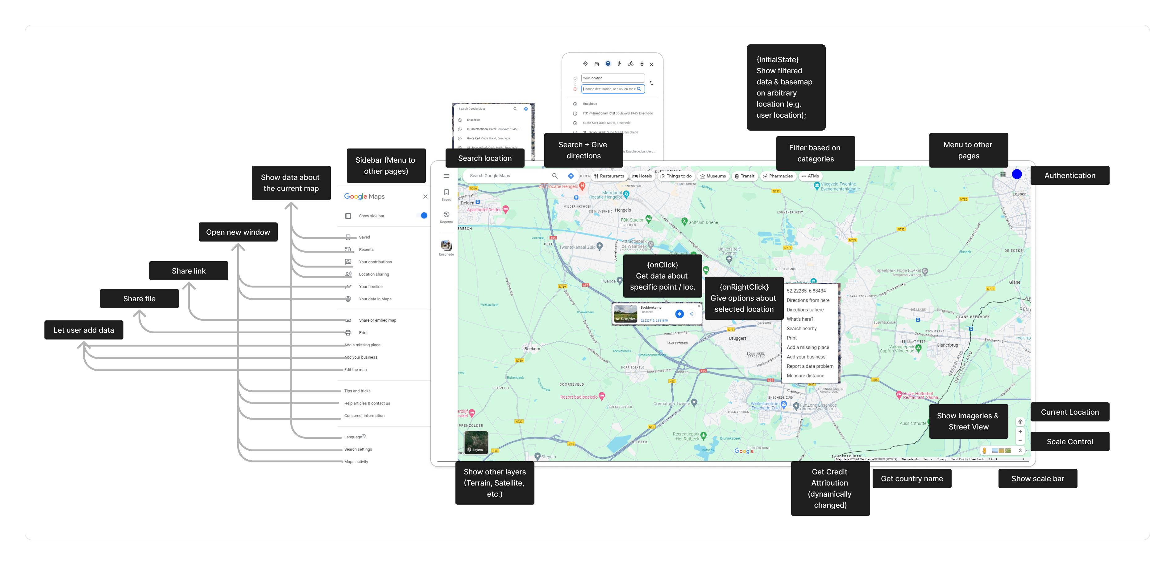Component that are found

* How many
* Explain per categorized functional requirements + reason for each

#### OpenStreetMap

Opening paragraph

* What is OpenStreetMap
* What is the purpose of OpenStreetMap
* Why OpenStreetMap is chosen

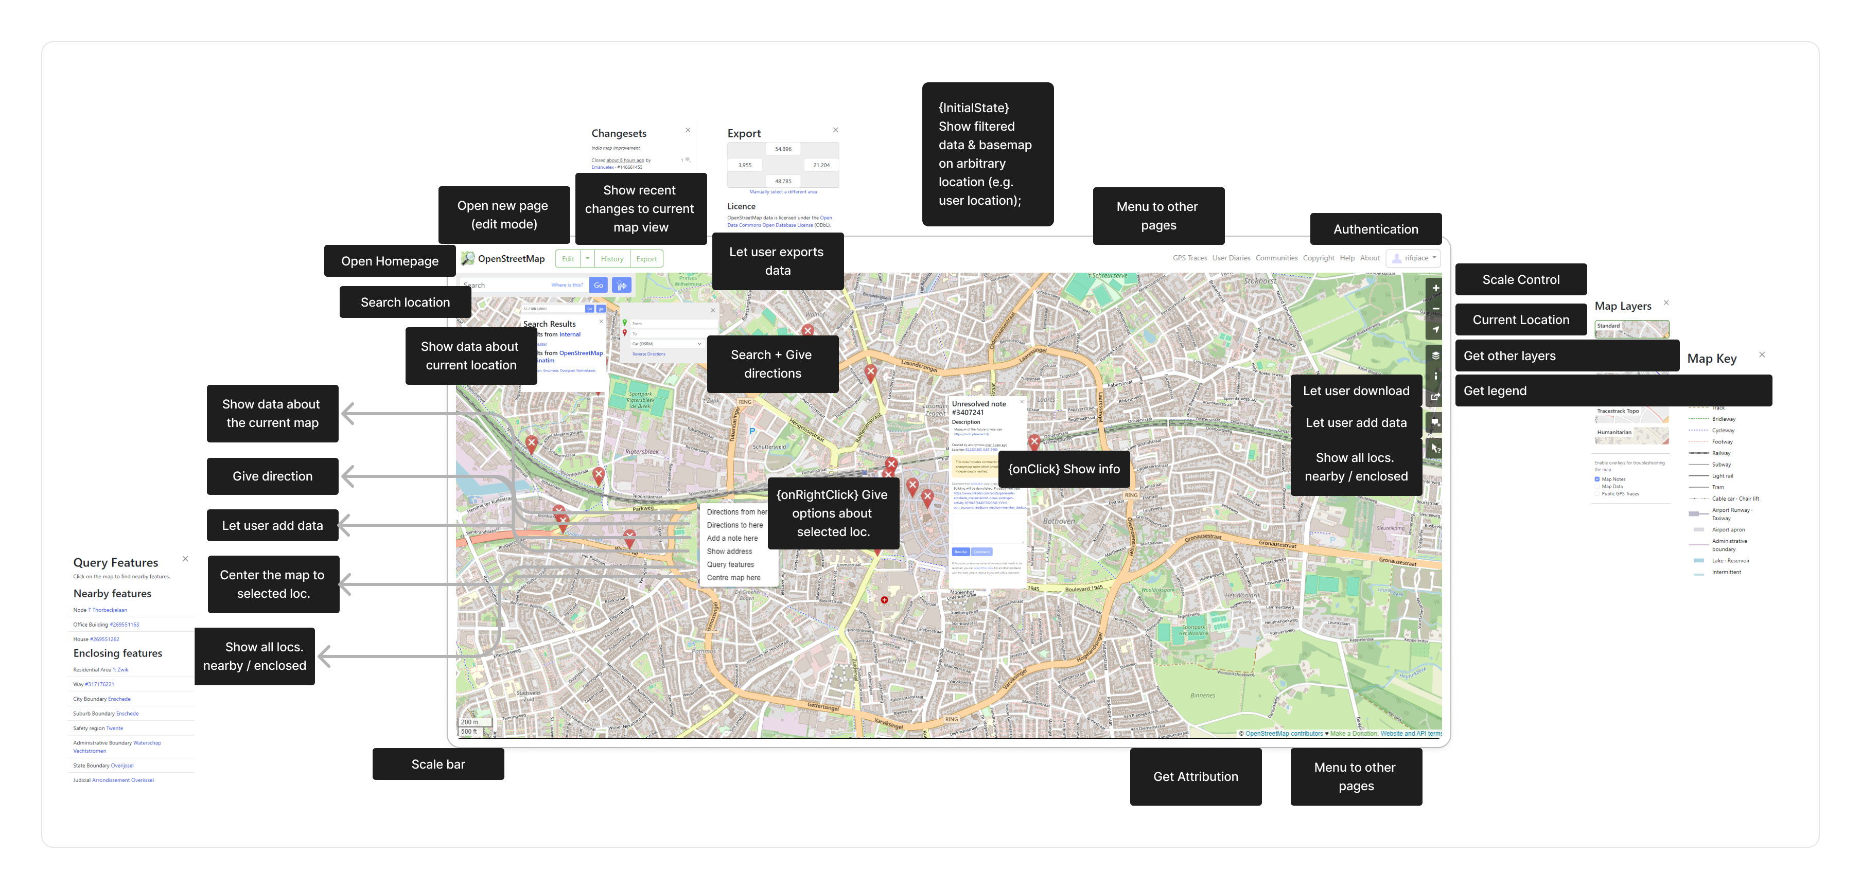Component that are found

* How many
* Explain per categorized functional requirements + reason for each

#### Earth Explorer

Opening paragraph

* What is Earth Explorer
* What is the purpose of Earth Explorer
* Why Earth Explorer is chosen

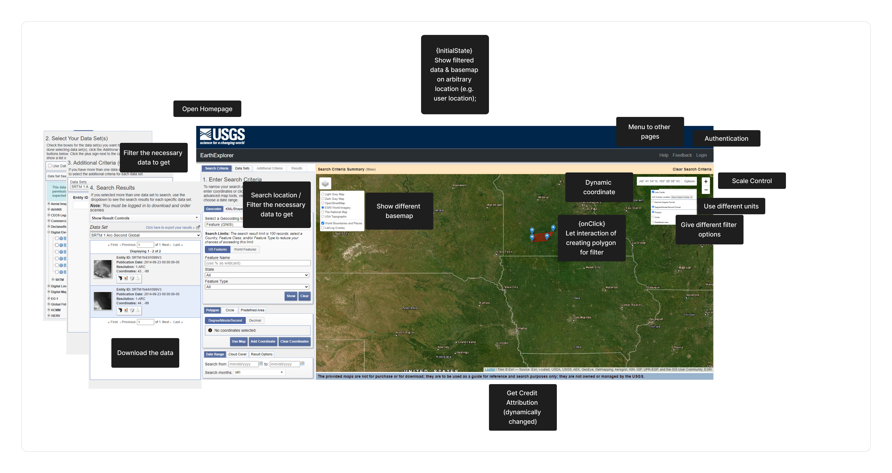Component that are found

* How many
* Explain per categorized functional requirements + reason for each

#### Samen Meten

Opening paragraph

* What is SamenMeten
* What is the purpose of SamenMeten
* Why SamenMeten is chosen

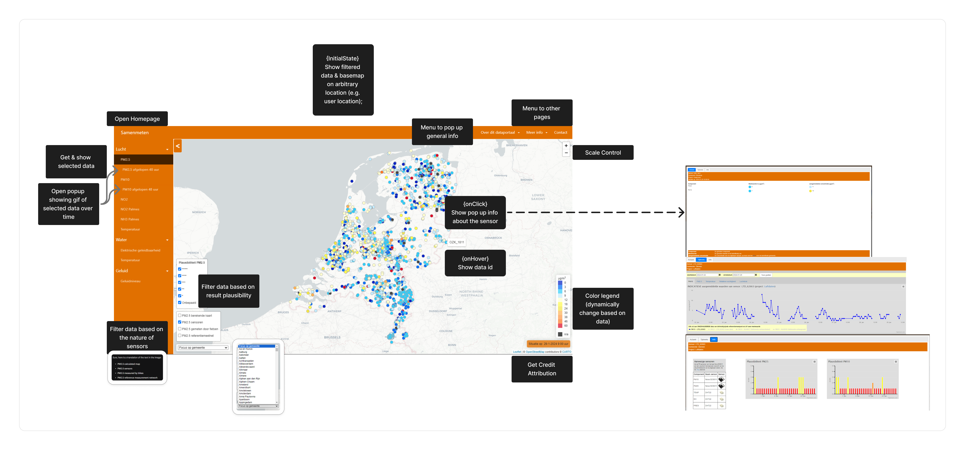Component that are found

* How many
* Explain per categorized functional requirements + reason for each

#### ShadeMap

Opening paragraph

* What is ShadeMap
* What is the purpose of ShadeMap
* Why ShadeMap is chosen

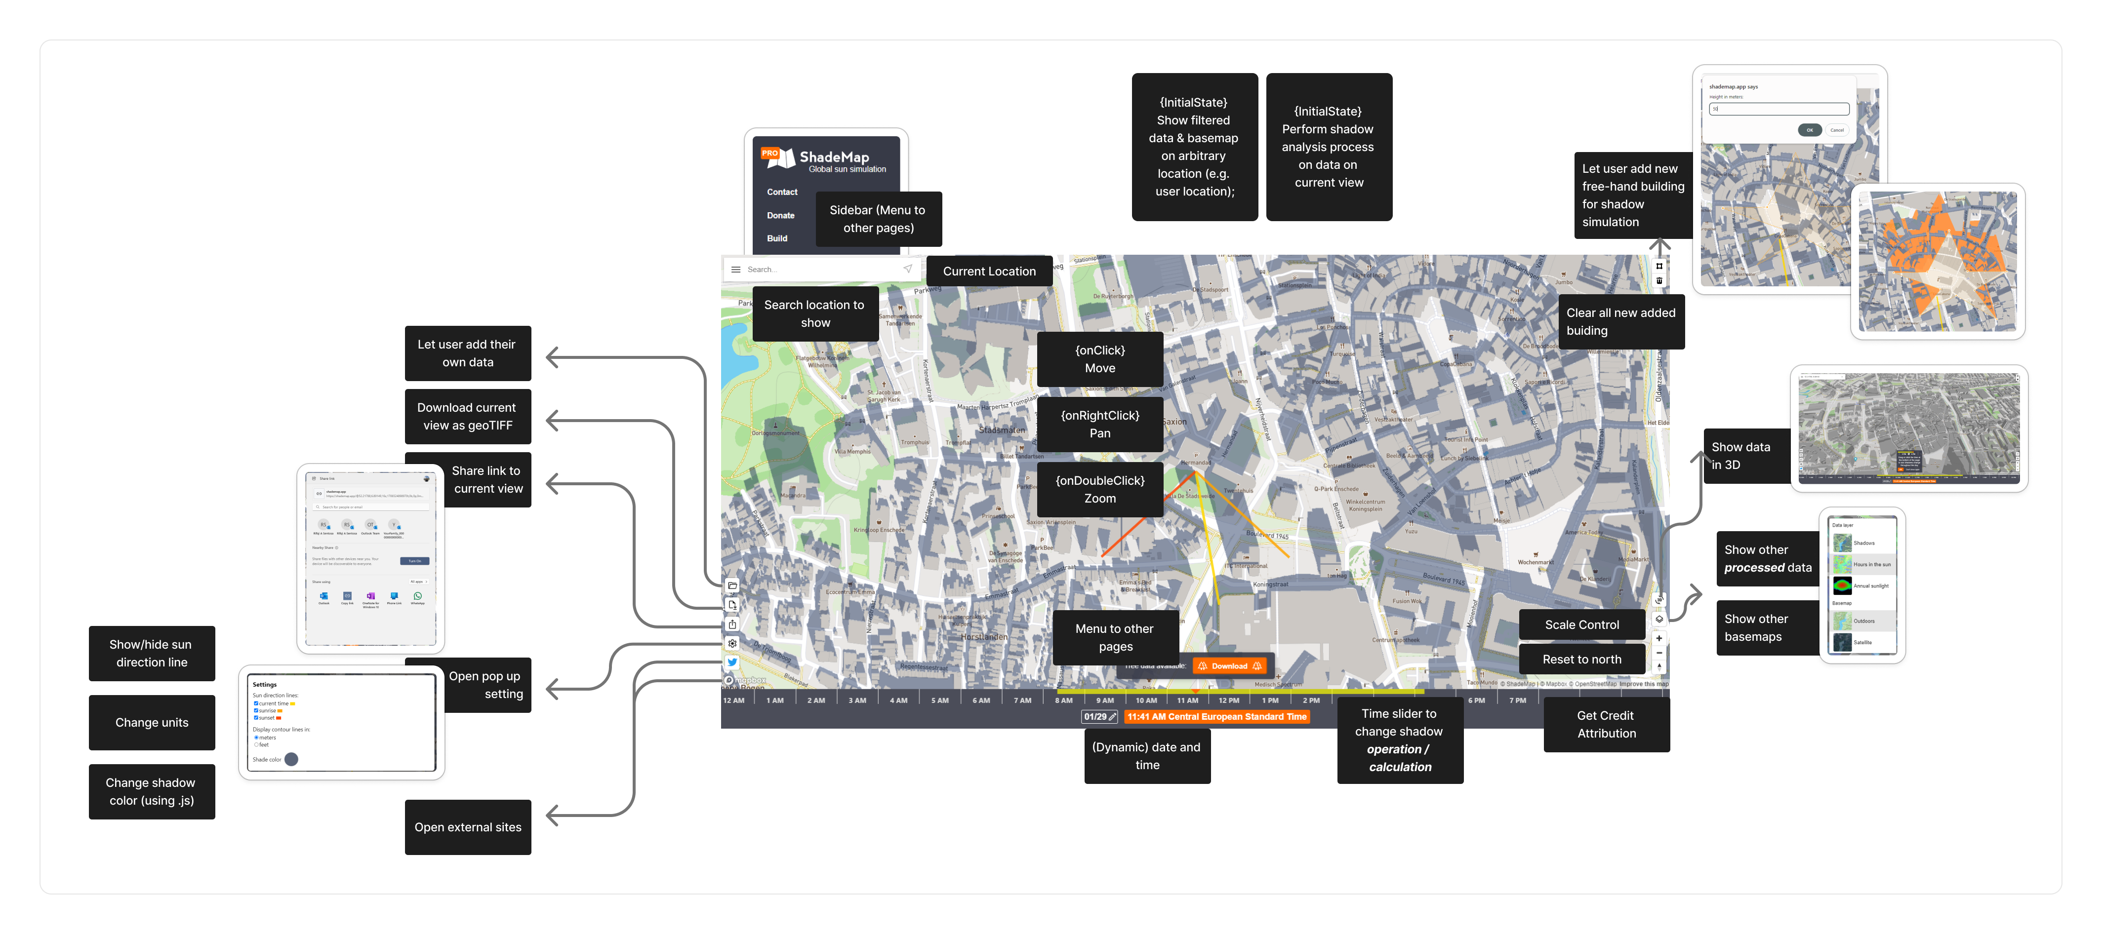Component that are found

* How many
* Explain per categorized functional requirements + reason for each

#### PDOK

Opening paragraph

* What is PDOK
* What is the purpose of PDOK
* Why PDOK is chosen

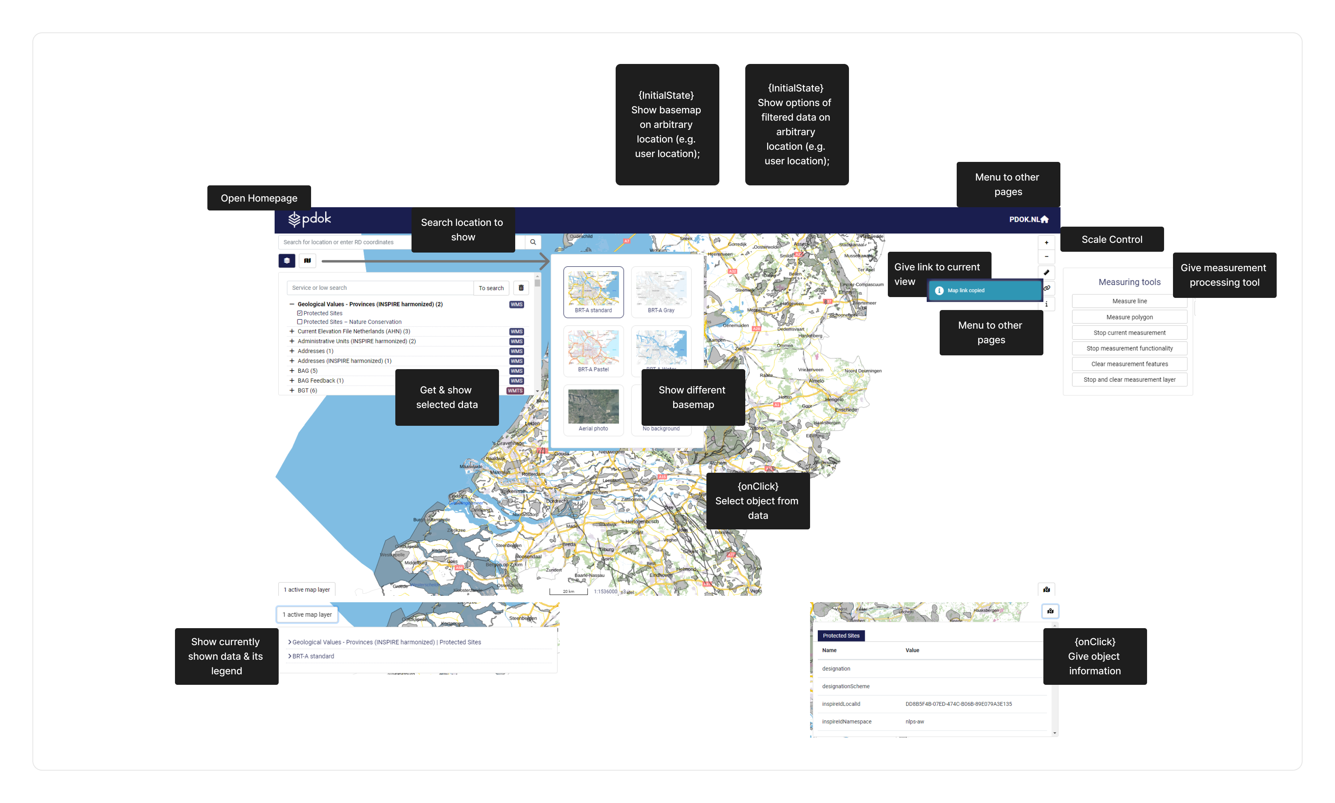Component that are found

* How many
* Explain per categorized functional requirements + reason for each

### Common Functions Identification

Opening paragraph of Common Functions Identification

* What the step is doing
  + Simply summarizing the common functions
* What the purpose
* Expected final result

Common functions:

1. Perform processes.
2. Open Other Resources.
3. Authentication.
4. Attribution.
5. Get Other Layer.
6. Initialization.
7. Filter Data to Show.
8. Show user's current location.
9. Scale control.
10. Scale bar.
11. Get info about selected location.
12. Let User Add Data.
13. Share Link.
14. Download Data.
15. Add Legend.
16. Custom right-click.
17. Use different units.
18. Change style.
19. Interact with currently shown view.
20. Move or orient current view.



Selecting 3 functions

* What the step is doing
  + Selecting the 3 components to be detailed
    - Reason for why these three: covers ranges of possible web app logics
      * Processes
      * Interactivity between components
      * Frontend-backend-data connections
    - Reason why
* What the purpose
  + For requirement analysis

## Requirement Analysis

Opening paragraph of requirement analysis

* User target
  + The reason why those users
  + What the users do by knowing this step
* What the step is doing
  + The selected 3 functions are analyzed
    - Analysis is done from the lens of REST principle and OGC API standards
  + Describing the sequence of actions and interactions between the user, front-end, and back-end components
* What the purpose
  + crucial for creating a comprehensive and accurate UML profile that reflects the actual behaviors and interactions within the web application, for the selected components.
* Expected final result
  + Descriptive form of functional requirements

### Search Location

Opening paragraph

* How common is this function in web application
  + Common UI components involved in this function.
* Why chosen: showcasing frontend-backend-data connections

Functional requirements

1. The user enters a location-based query into the search bar. It could take various forms:
   * Keyword search: the name of a place e.g. city.
   * Spatial search: a specific coordinate or a bounding box.
2. The user initiates the search by pressing "Enter" or clicking a search button.
3. The front-end code constructs an HTTP GET request with appropriate query parameters.
4. The backend server parses the HTTP request to extract relevant information from the query parameters.
5. The request is routed to the specific geospatial module or service within the backend, such as a geospatial search service or a geocoding service.
6. The geospatial module or service executes the necessary operations based on the type of geospatial search requested.
7. Geospatial services may interact with the geospatial data source to retrieve relevant information.
8. Once the data is retrieved, the backend performs additional processing, such as transforming the raw data into GeoJSON format.
9. The geospatial service generates the HTTP response in a standardized format (e.g. GeoJSON) and sends it back to the front end using standard parsing libraries compatible with GeoJSON.
10. The front end parses the HTTP response to extract the relevant information.
11. The front end processes the retrieved information to update the user interface with the search results.

Summary

* Summary the list as a short paragraph.

How the functional requirements comply with everything.

* How it complies with REST architecture principle.
* How it complies with OGC API Standards + OpenAPI specifications

### Measure Distance

Opening paragraph

* How common is this function in web application.
  + Common UI components involved in this function.
* Why chosen: showcasing how to perform processes.

Functional requirements:

1. The user initiates a distance measurement process by interacting with provided interface.
2. The user selects two points on the map for distance measurement. Event listener attached to the interface detects this interaction.
3. The frontend sends a POST request to the backend server to initiate the distance measurement. The request contains a JSON payload with the selected points and measurement parameters.
4. The backend server parses the HTTP request to extract relevant information. The server validates the input data.
5. The backend creates a job resource to handle the distance measurement task. A unique identifier is assigned to the job. The server responds with a 202 Accepted status and a URL to poll for job status.
6. The distance measurement is performed by the appropriate module or service.
7. The frontend periodically checks the status of the job by sending a GET request to the job URL.
8. When the distance measurement is complete, the backend updates the job resource with the result.
9. The frontend updates the user interface to display the measured distance.

Summary

* Summary the list as a short paragraph.

How the functional requirements comply with everything.

* How it complies with REST architecture principle.
* How it complies with OGC API Standards + OpenAPI specifications

### Select Basemap Layer

Opening paragraph

* How common is this function in web application.
  + Common UI components involved in this function.
* Why chosen: showcasing the interaction between components.

Technical requirements:

1. During the initialization of map visualization in the application, a section of the UI provides an option list or dropdown menu for selecting basemap layers. The frontend sends an HTTP GET request to the backend for metadata of the available basemap layers and displays the response in a dedicated section.
2. en a user selects a basemap layer from the dropdown, the frontend sends an HTTP GET request to the backend, specifying the selected basemap layer.
3. The backend parses the HTTP request and fetches the data associated with the selected basemap layer.
4. The backend sends the requested data (or alternatively tiles) back to the frontend by generating HTTP 200 response.
5. The frontend parses the HTTP response to retrieve the data or tiles from the backend.
6. The frontend updates the map, replacing the current basemap layer with the newly selected one. If the backend provided raw data, the frontend might need to render the basemap layer.
7. The user can interact with the map, such as panning or zooming. The frontend sends additional GET requests to the backend for tiles covering the newly visible area.

Summary

* Summary the list as a short paragraph.

How the functional requirements comply with everything.

* How it complies with REST architecture principle.
* How it complies with OGC API Standards + OpenAPI specifications

## UML Profile Development

*Detail step: conceptual modeling*

*Detail step: UML profile for PIM*

*Detail step: UML profile for PSM*

This section explains the development of UML profile following the technical analyses resulted from the previous requirement analysis phase. This section is targeted appropriately for *Developer* user type of this thesis only, since this phase is still included in development of the approach. By knowing and applying this phase, the targeted user will understand the proposed approach to build the UML profile that both capture the conceptual model of REST-based geospatial web application in multiple level of abstractions and will be used practically for the implementation in developing the REST-based geospatial web application using MDA approach.

This phase continues the detailed technical analyses from the previous requirement analysis step which has included the observed REST-based geospatial web application components, the concept of REST architecture and OGC API standards inside it. The purpose of taking this phase is to develop two UML profiles with contained stereotypes to provide the two MDA level of abstractions: Platform Independent Model (PIM) and Platform Specific Model (PSM). This phase translates the preceding analyses phases to the designing phase and lead to the implementation of every concepts that has been captured. The final result of this phase will be UML profile for developing PIM and PSM.

This phase explains in detail the steps contained to achieve the final result, namely the conceptual modeling process of the functional requirements, the development of PIM and PSM profile using the conceptualized model, and the model transformations to connect both abstractions model to generate code that later becomes the source code of a developed REST-based geospatial web application.

### Conceptual Model

This step conceptualized the three analyzed functional requirements using UML class concept. Since REST principle and OGC API standards have been applied as the lens in analyzing the functional requirements, the UML classes resulted from this step should capture the requirements that allow development of REST-based geospatial web application that abide with the principle and standards. This step bridges the gap between analysis step to designing step of this research.

First, the step summarized all nouns and verbs contained from the functional requirements. *(… Why nouns and verbs approach is used. Nouns for potential class and attribute name, verbs for potential operations and association. Citation might be needed …)*. The items captured in the summary table is then observed on whether it can be potential UML class, attribute, operation, or association. Table XXX shows the summary of all nouns and verbs.

The first noun to be captured is *user*. This semantic is captured from all three functional requirements as *user* should be present to interact with the geospatial web application. The user is closely related to all interactions with geospatial web application. Since user will be interacting with all elements in a geospatial web application and “designing the user” is not an appropriate perspective during designing the components of geospatial web application, it is decided to put more emphasis on *user interaction* to represent the *user* element that is closely coherent with the components which allow appropriate designing process.

Multiple verbs that relate to *user* are as follow:

* *Enter*. This verb represents the possible event when a user *enters* some inputs to the geospatial web application using provided UI component, such as entering location query using search bar.
* Initiate. This verb represents …
* Press. …
* Click. …
* Interact. …
* Select. …

The next noun is …

(table is below, should be moved up) Table of nouns and verbs as a step of conceptual modeling



Based on the analysis and considerations to each items in the summary table, several classes are generated as shown in Figure XXX. The classes are intentionally structured in three separate columns to apply MVC design pattern. *(… Introduction to MVC pattern. Why MVC is chosen and benefits of applying it to this step. Citation might be needed …)*. The UML classes resulted in this phase are not using many UML capabilities such as multiplicity and associations, which will be applied during the development of UML profile.

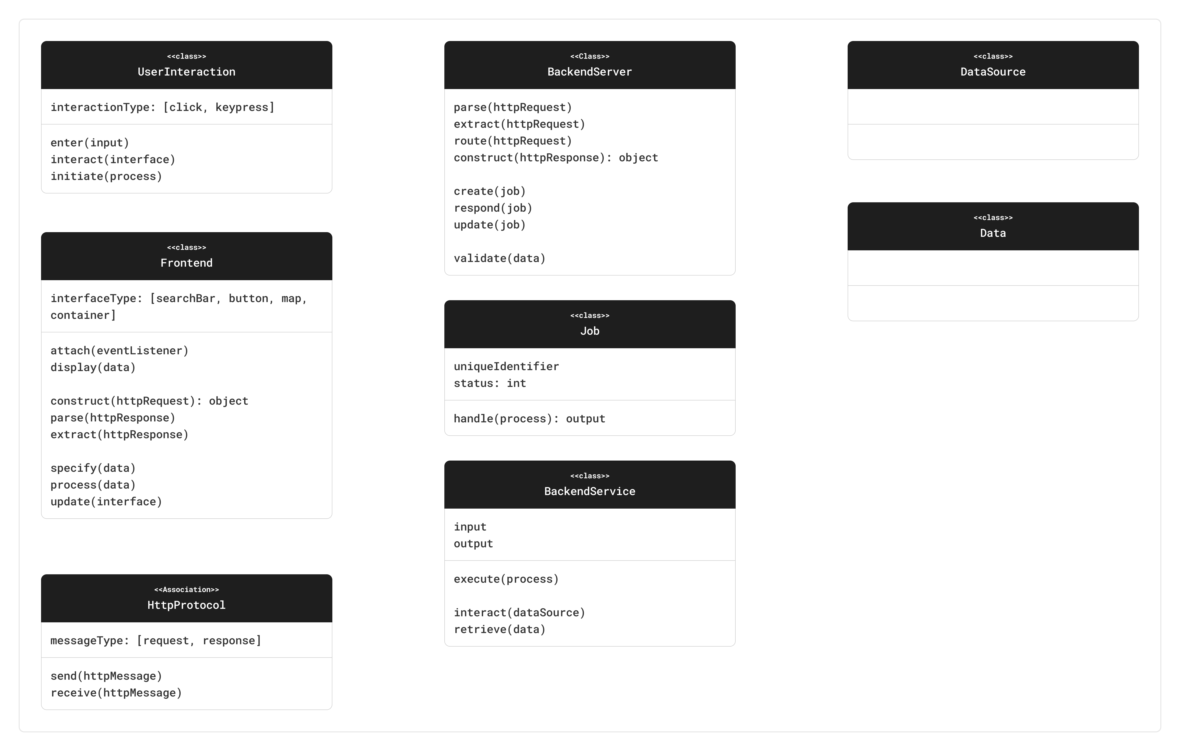

The class *UserInteraction* represents interactions that are captured from the functional requirements. It covers all possible interactions a user might perform with a geospatial web application. The attribute *interactionType* provide the mean to specify what kind of interaction a user perform in any arbitrary instance of this class, examples from the functional requirements are *click* to represent any kind of mouse clicks and *keypress* to represent any kind of keyboard presses. The operation enter represents the possibility of a user to enter an input to geospatial web application. The operation *interact* represent the possibility of a user to interact with UI elements of geospatial web application and perform any interaction types that are defined in the *interactionType* attribute. The operation *initiate* represents the possibility of a user to perform a process by interacting with provided UI component in the geospatial web application interface.

The class *Frontend* represents …

Additional reasoning behind the UML classes

* Why some are generalized + example
* Why some are ditched + example

PIM and PSM profile separation

* Which classes come to PIM profile
  + Reason why:
    - Platform independent
    - Focus on users’ limited concern in building PIM
* Which classes come to PSM profile
  + Reason why
    - Platform dependent
    - Focus on users’ limited concern in building PIM

### PIM Profile Development

Opening paragraph of PIM profile development

* What the step is doing
  + Expanding the conceptual UML model into usable UML profile
* What the purpose
* Briefly introduce potential use of this to all targeted users
  + Which will be detailed in later demonstration section

Introducing the diagram below:

* What we are seeing in the diagram
  + What is <<pkg>>
  + What is <<profile>>
  + What is the arrow

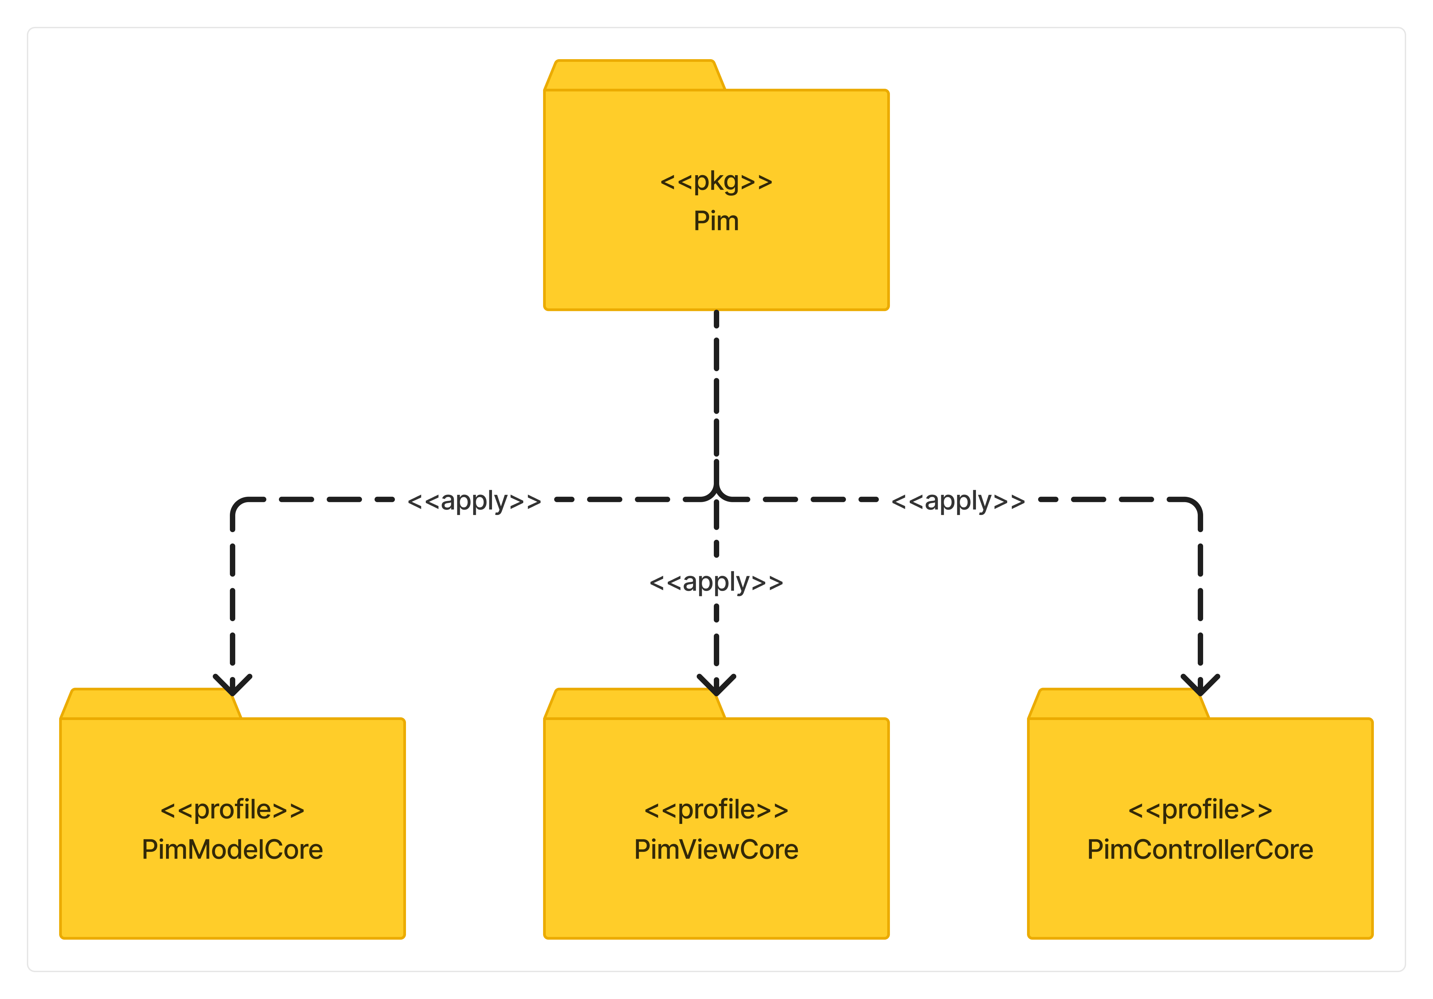

What should be the PIM profile looks like

* Splitting and expanding the conceptual model result
  + What are the class for PIM profile.
    - The reason why they are chosen to be included in PIM profile.
* MVC separated profile.
  + Continuing the separation of concern
  + Class + Association relationship
    - Helping the connection between classes within and across profile
* Briefly introduce the explanatory subsections below

#### PIM MVC-Model Profile

*Only exclusively talk about why the profile being made like this; not how to use it. For that part, there will be a separate section about it*

Opening paragraph of PIM MVC-Model

* What is this profile.
* The purpose of having this profile
* The brief introduction of what is inside this profile.



Overview explanation

* What is inside this profile
  + Classes
  + Associations
* The reason why

Explanation – Dataset class

* What is it.
  + Definition
  + The reason why it is like that.
* The reason is it present here.
* The reason why it inherits a certain parent class if any
* Attributes
  + The reason why it is like that.
* Operations
  + The reason why it is like that.

Explanation – Spatial Dataset class

* What is it.
  + Definition
  + The reason why it is like that.
* The reason is it present here.
* The reason why it inherits a certain parent class if any
* Attributes
  + The reason why it is like that.
* Operations
  + The reason why it is like that.

Explanation – Vector Dataset class

* What is it.
  + Definition
  + The reason why it is like that.
* The reason is it present here.
* The reason why it inherits a certain parent class if any
* Attributes
  + The reason why it is like that.
* Operations
  + The reason why it is like that.

Explanation – Raster Dataset class

* What is it.
  + Definition
  + The reason why it is like that.
* The reason is it present here.
* The reason why it inherits a certain parent class if any
* Attributes
  + The reason why it is like that.
* Operations
  + The reason why it is like that.

Explanation – Non Spatial Dataset class

* What is it.
  + Definition
  + The reason why it is like that.
* The reason is it present here.
* The reason why it inherits a certain parent class if any
* Attributes
  + The reason why it is like that.
* Operations
  + The reason why it is like that.

Explanation – Data Service

Explanation – Spatial Data Service

Explanation – Web Feature Service

Explanation – Web Map Service

Explanation – Vector Tile Service

Explanation – Raster Tile Service

Explanation – Non Spatial Data Service

Explanation – Data Store

Explanation – Local Data Store

Explanation – Cloud Data Store

Explanation – Offer association

Explanation – Display association

Explanation – Process association

#### PIM MVC-View Profile

*Only exclusively talk about why the profile being made like this; not how to use it. For that part, there will be a separate section about it*

Opening paragraph of PIM MVC-View

* What is this profile
* The purpose of having this profile
* The brief introduction of what is inside this profile

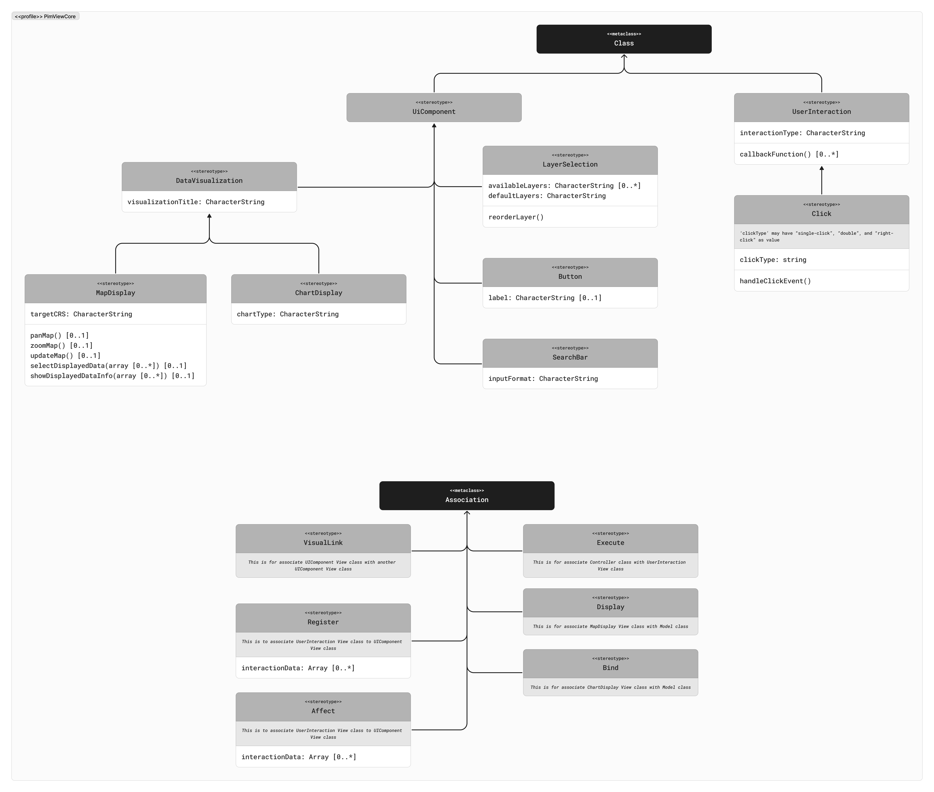

Overview explanation

* What is inside this profile
  + Classes
  + Associations
* The reason why

Explanation – UI component

* What is it.
  + Definition
  + The reason why it is like that.
* The reason is it present here.
* The reason why it inherits a certain parent class if any
* Attributes
  + The reason why it is like that.
* Operations
  + The reason why it is like that.

Explanation – Data Visualization

* What is it.
  + Definition
  + The reason why it is like that.
* The reason is it present here.
* The reason why it inherits a certain parent class if any
* Attributes
  + The reason why it is like that.
* Operations
  + The reason why it is like that.

Explanation – Map Display

* What is it.
  + Definition
  + The reason why it is like that.
* The reason is it present here.
* The reason why it inherits a certain parent class if any
* Attributes
  + The reason why it is like that.
* Operations
  + The reason why it is like that.

Explanation – Chart Display

* What is it.
  + Definition
  + The reason why it is like that.
* The reason is it present here.
* The reason why it inherits a certain parent class if any
* Attributes
  + The reason why it is like that.
* Operations
  + The reason why it is like that.

Explanation – Layer Selection

* What is it.
  + Definition
  + The reason why it is like that.
* The reason is it present here.
* The reason why it inherits a certain parent class if any
* Attributes
  + The reason why it is like that.
* Operations
  + The reason why it is like that.

Explanation – Button

* What is it.
  + Definition
  + The reason why it is like that.
* The reason is it present here.
* The reason why it inherits a certain parent class if any
* Attributes
  + The reason why it is like that.
* Operations
  + The reason why it is like that.

Explanation – Search Bar

* What is it.
  + Definition
  + The reason why it is like that.
* The reason is it present here.
* The reason why it inherits a certain parent class if any
* Attributes
  + The reason why it is like that.
* Operations
  + The reason why it is like that.

Explanation – Visual Link

* What is it.
  + Definition
  + The reason why it is like that.
* The reason is it present here.
* The reason why it inherits a certain parent class if any
* Attributes
  + The reason why it is like that.
* Operations
  + The reason why it is like that.

Explanation – Register

* What is it.
  + Definition
  + The reason why it is like that.
* The reason is it present here.
* The reason why it inherits a certain parent class if any
* Attributes
  + The reason why it is like that.
* Operations
  + The reason why it is like that.

Explanation – Affect

* What is it.
  + Definition
  + The reason why it is like that.
* The reason is it present here.
* The reason why it inherits a certain parent class if any
* Attributes
  + The reason why it is like that.
* Operations
  + The reason why it is like that.

Explanation – Execute

* What is it.
  + Definition
  + The reason why it is like that.
* The reason is it present here.
* The reason why it inherits a certain parent class if any
* Attributes
  + The reason why it is like that.
* Operations
  + The reason why it is like that.

Explanation – Display

* What is it.
  + Definition
  + The reason why it is like that.
* The reason is it present here.
* The reason why it inherits a certain parent class if any
* Attributes
  + The reason why it is like that.
* Operations
  + The reason why it is like that.

Explanation – Bind

* What is it.
  + Definition
  + The reason why it is like that.
* The reason is it present here.
* The reason why it inherits a certain parent class if any
* Attributes
  + The reason why it is like that.
* Operations
  + The reason why it is like that.

#### PIM MVC-Controller Profile

*Only exclusively talk about why the profile being made like this; not how to use it. For that part, there will be a separate section about it*

Opening paragraph of PIM MVC-Controller

* What is this profile
* The purpose of having this profile
* The brief introduction of what is inside this profile

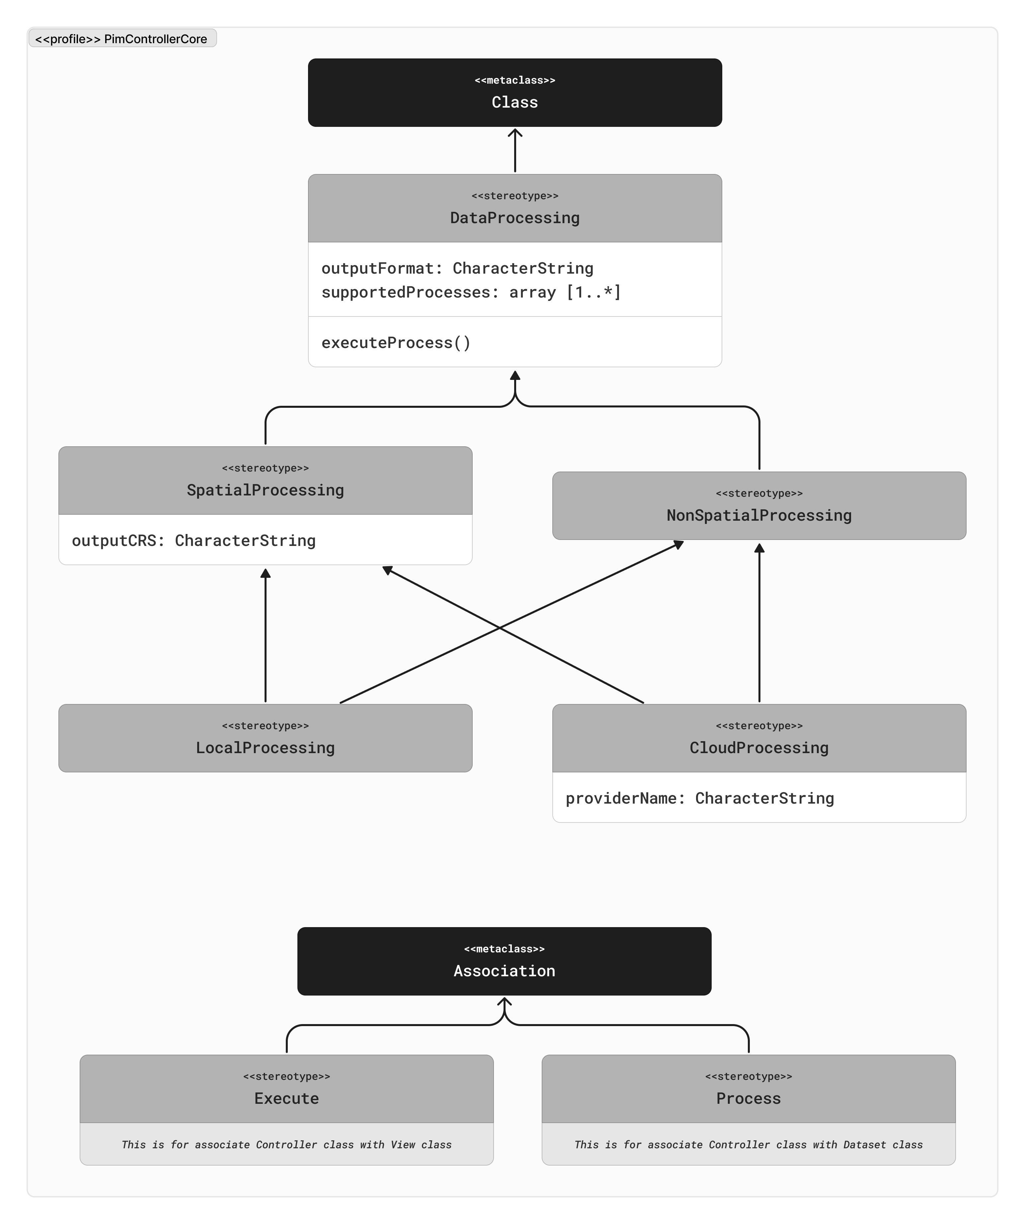

Overview explanation

* What is inside this profile
  + Classes
  + Associations
* The reason why

Explanation – Data Processing

* What is it.
  + Definition
  + The reason why it is like that.
* The reason is it present here.
* The reason why it inherits a certain parent class if any
* Attributes
  + The reason why it is like that.
* Operations
  + The reason why it is like that.

Explanation – Spatial Processing

* What is it.
  + Definition
  + The reason why it is like that.
* The reason is it present here.
* The reason why it inherits a certain parent class if any
* Attributes
  + The reason why it is like that.
* Operations
  + The reason why it is like that.

Explanation – Non Spatial Processing

* What is it.
  + Definition
  + The reason why it is like that.
* The reason is it present here.
* The reason why it inherits a certain parent class if any
* Attributes
  + The reason why it is like that.
* Operations
  + The reason why it is like that.

Explanation – Local Processing

* What is it.
  + Definition
  + The reason why it is like that.
* The reason is it present here.
* The reason why it inherits a certain parent class if any
* Attributes
  + The reason why it is like that.
* Operations
  + The reason why it is like that.

Explanation – Clod Processing

* What is it.
  + Definition
  + The reason why it is like that.
* The reason is it present here.
* The reason why it inherits a certain parent class if any
* Attributes
  + The reason why it is like that.
* Operations
  + The reason why it is like that.

Explanation – Execute association

* What is it.
  + Definition
  + The reason why it is like that.
* The reason is it present here.
* The reason why it inherits a certain parent class if any
* Attributes
  + The reason why it is like that.
* Operations
  + The reason why it is like that.

Explanation – Process association

* What is it.
  + Definition
  + The reason why it is like that.
* The reason is it present here.
* The reason why it inherits a certain parent class if any
* Attributes
  + The reason why it is like that.
* Operations
  + The reason why it is like that.

### PSM Profile Development

Opening paragraph of PSM profile development

* What the step is doing
  + Expanding the conceptual UML model into usable UML profile
* What the purpose
* Briefly introduce potential use of this to all targeted users
  + Which will be detailed in later demonstration section

Introducing the diagram below:

* What we are seeing in the diagram
  + What is <<pkg>>
  + What is <<profile>>
  + What is the arrow

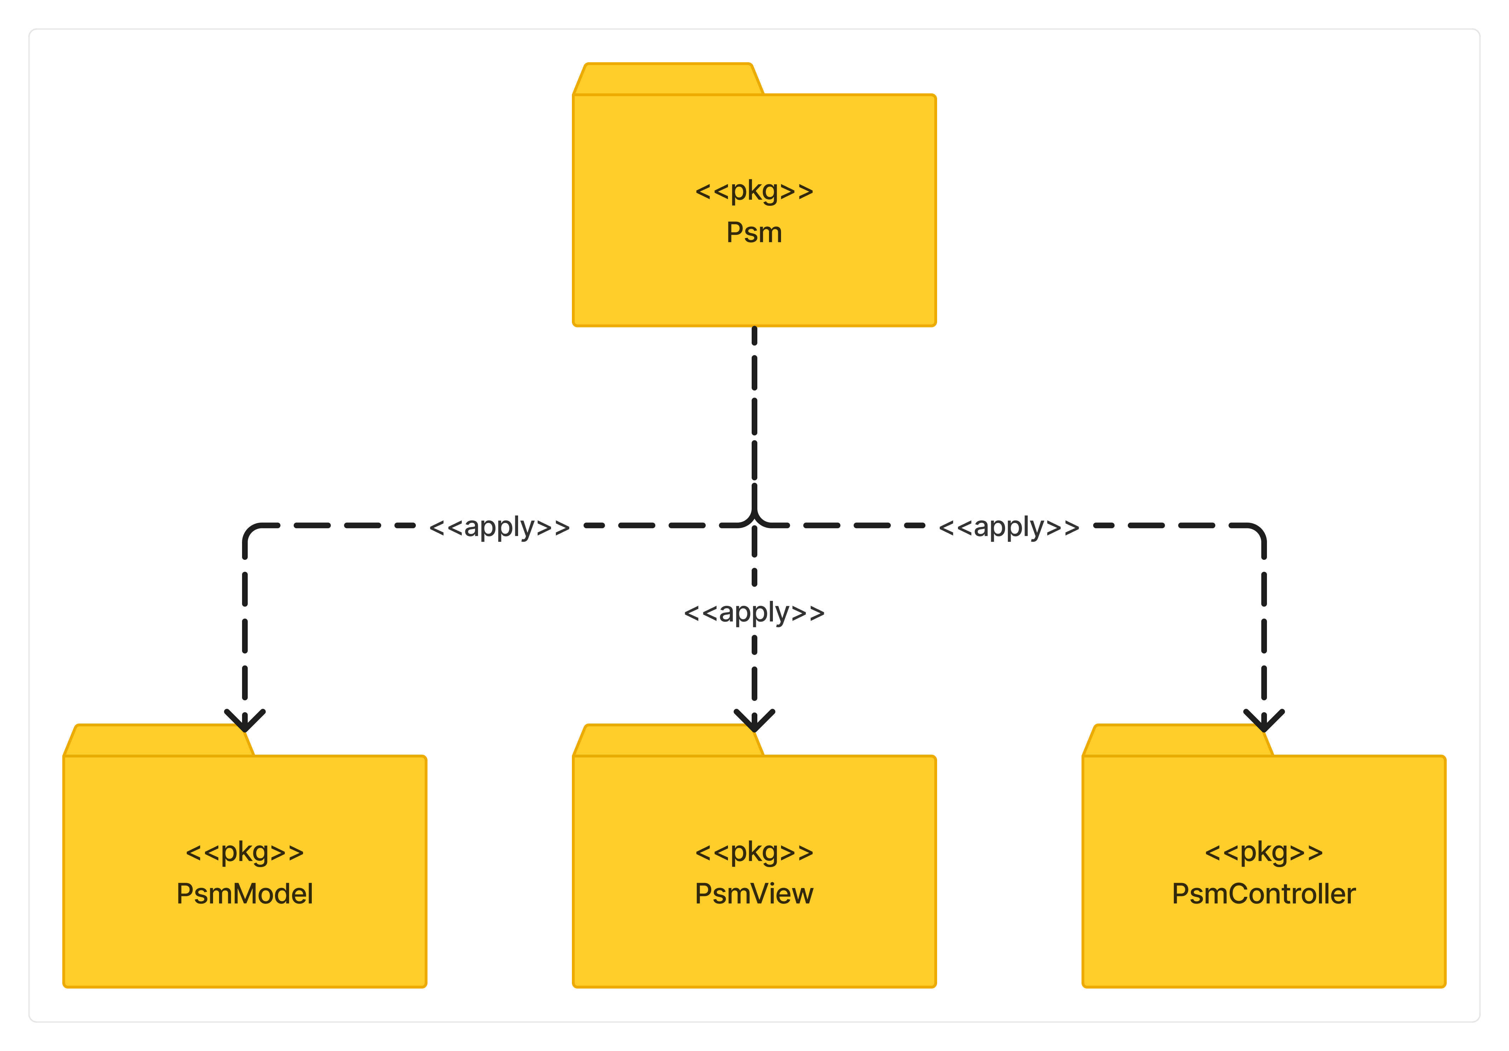

What should be the PSM profile looks like

* Splitting and expanding the conceptual model result
  + What are the class for PSM profile.
    - The reason why they are chosen to be included in PSM profile.
* MVC separated package.
  + Continuing the separation of concern
  + Packages contain core + technology-related profile
  + Class + Association relationship
    - Helping the connection between classes within and across profile
* Briefly introduce the explanatory subsections below

#### PSM MVC-Model Package

*Only exclusively talk about why the profile being made like this; not how to use it. For that part, there will be a separate section about it.*

*Everything in “Core” package is only to conveniently provide parent classes to be inherited from; so it will not cover many platform-dependent classes and elements.*

Opening paragraph of PSM MVC-Model package

* What is this package.
* The purpose of having this package
* The brief introduction of what is inside this package.

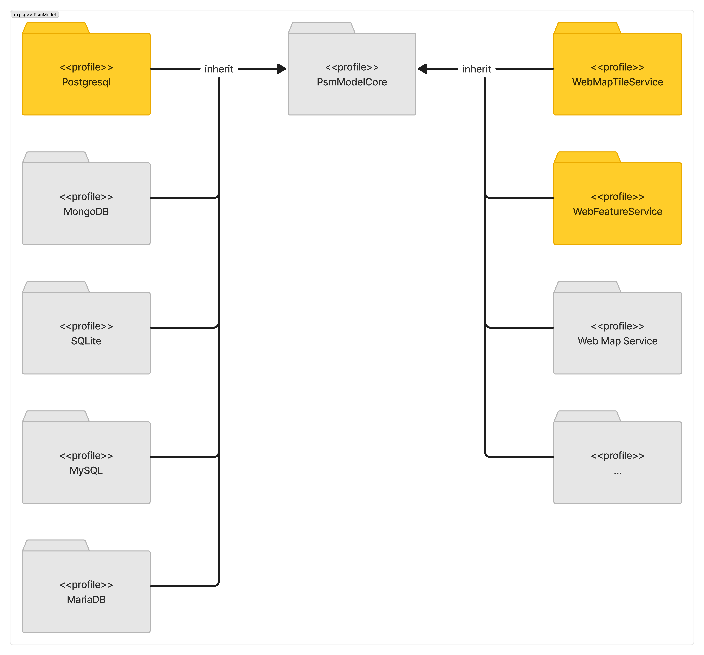

Opening paragraph of Postgresql

* What is this profile.
* The purpose of having this profile.
  + only to conveniently provide parent classes to be inherited from; so it will not cover many platform-dependent classes and elements
* The brief introduction of what is inside this profile.

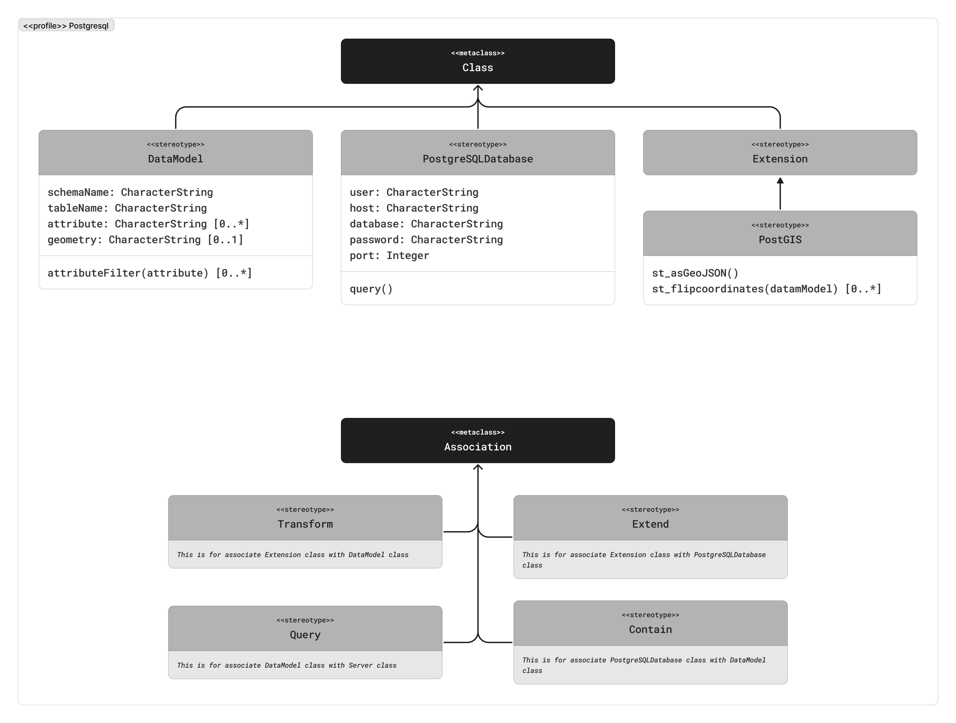

Overview explanation.

* What is inside this profile.
  + Classes
  + Associations
* The reason why

Explanation – Data Model

* What is it.
  + Definition
  + The reason why it is like that.
* The reason is it present here.
* The reason why it inherits a certain parent class if any
* Attributes
  + The reason why it is like that.
* Operations
  + The reason why it is like that.

Explanation – PostgreSQL Database

* What is it.
  + Definition
  + The reason why it is like that.
* The reason is it present here.
* The reason why it inherits a certain parent class if any
* Attributes
  + The reason why it is like that.
* Operations
  + The reason why it is like that.

Explanation – Extension

* What is it.
  + Definition
  + The reason why it is like that.
* The reason is it present here.
* The reason why it inherits a certain parent class if any
* Attributes
  + The reason why it is like that.
* Operations
  + The reason why it is like that.

Explanation – PostGIS

* What is it.
  + Definition
  + The reason why it is like that.
* The reason is it present here.
* The reason why it inherits a certain parent class if any
* Attributes
  + The reason why it is like that.
* Operations
  + The reason why it is like that.

Explanation – Query

* What is it.
  + Definition
  + The reason why it is like that.
* The reason is it present here.
* The reason why it inherits a certain parent class if any
* Attributes
  + The reason why it is like that.
* Operations
  + The reason why it is like that.

Explanation – Extend

* What is it.
  + Definition
  + The reason why it is like that.
* The reason is it present here.
* The reason why it inherits a certain parent class if any
* Attributes
  + The reason why it is like that.
* Operations
  + The reason why it is like that.

Explanation – Contain

* What is it.
  + Definition
  + The reason why it is like that.
* The reason is it present here.
* The reason why it inherits a certain parent class if any
* Attributes
  + The reason why it is like that.
* Operations
  + The reason why it is like that.

Explanation – Transform

* What is it.
  + Definition
  + The reason why it is like that.
* The reason is it present here.
* The reason why it inherits a certain parent class if any
* Attributes
  + The reason why it is like that.
* Operations
  + The reason why it is like that.

Opening paragraph of Web Feature Service

* What is this profile.
* The purpose of having this profile.
  + only to conveniently provide parent classes to be inherited from; so it will not cover many platform-dependent classes and elements
* The brief introduction of what is inside this profile.

Opening paragraph of Web Map Tile Service

* What is this profile.
* The purpose of having this profile.
  + only to conveniently provide parent classes to be inherited from; so it will not cover many platform-dependent classes and elements
* The brief introduction of what is inside this profile.

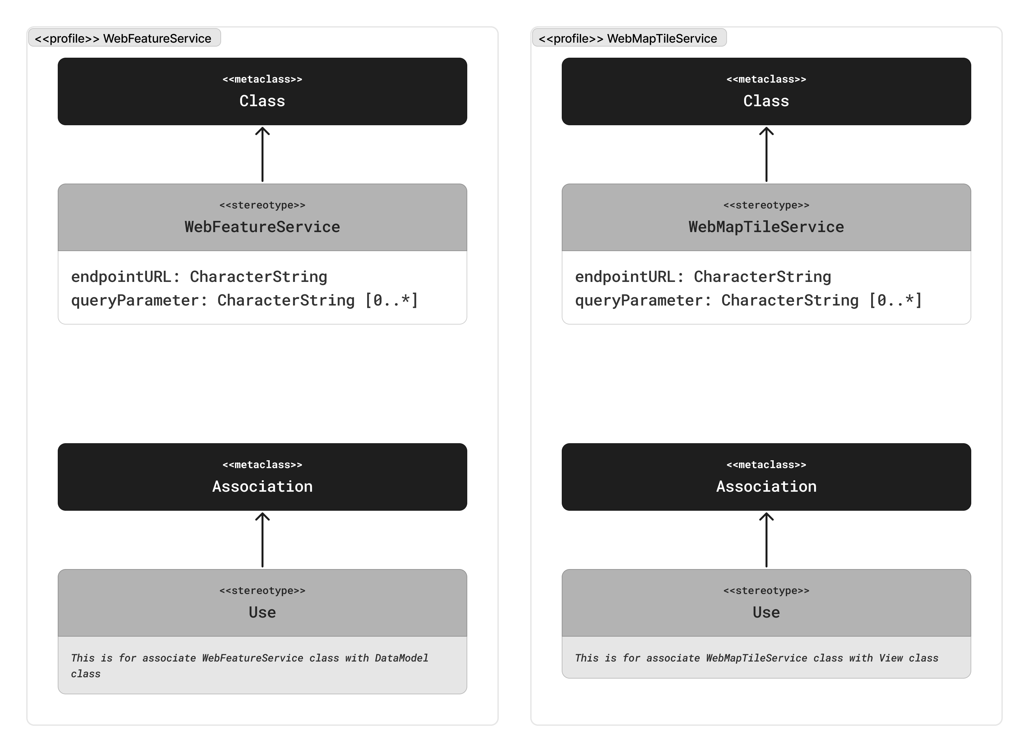

### WFS

Overview explanation.

* What is inside this profile.
  + Classes
  + Associations
* The reason why

Explanation – Web Feature Service

* What is it.
  + Definition
  + The reason why it is like that.
* The reason is it present here.
* The reason why it inherits a certain parent class if any
* Attributes
  + The reason why it is like that.
* Operations
  + The reason why it is like that.

Explanation – Use

* What is it.
  + Definition
  + The reason why it is like that.
* The reason is it present here.
* The reason why it inherits a certain parent class if any
* Attributes
  + The reason why it is like that.
* Operations
  + The reason why it is like that.

### WMTS

Overview explanation.

* What is inside this profile.
  + Classes
  + Associations
* The reason why

Explanation – Web Feature Service

* What is it.
  + Definition
  + The reason why it is like that.
* The reason is it present here.
* The reason why it inherits a certain parent class if any
* Attributes
  + The reason why it is like that.
* Operations
  + The reason why it is like that.

Explanation – Use

* What is it.
  + Definition
  + The reason why it is like that.
* The reason is it present here.
* The reason why it inherits a certain parent class if any
* Attributes
  + The reason why it is like that.
* Operations
  + The reason why it is like that.

#### PSM MVC-View Package

*Only exclusively talk about why the profile being made like this; not how to use it. For that part, there will be a separate section about it.*

*Everything in “Core” package is only to conveniently provide parent classes to be inherited from; so it will not cover many platform-dependent classes and elements.*

Opening paragraph of PSM MVC-View package

* What is this package.
* The purpose of having this package
* The brief introduction of what is inside this package.

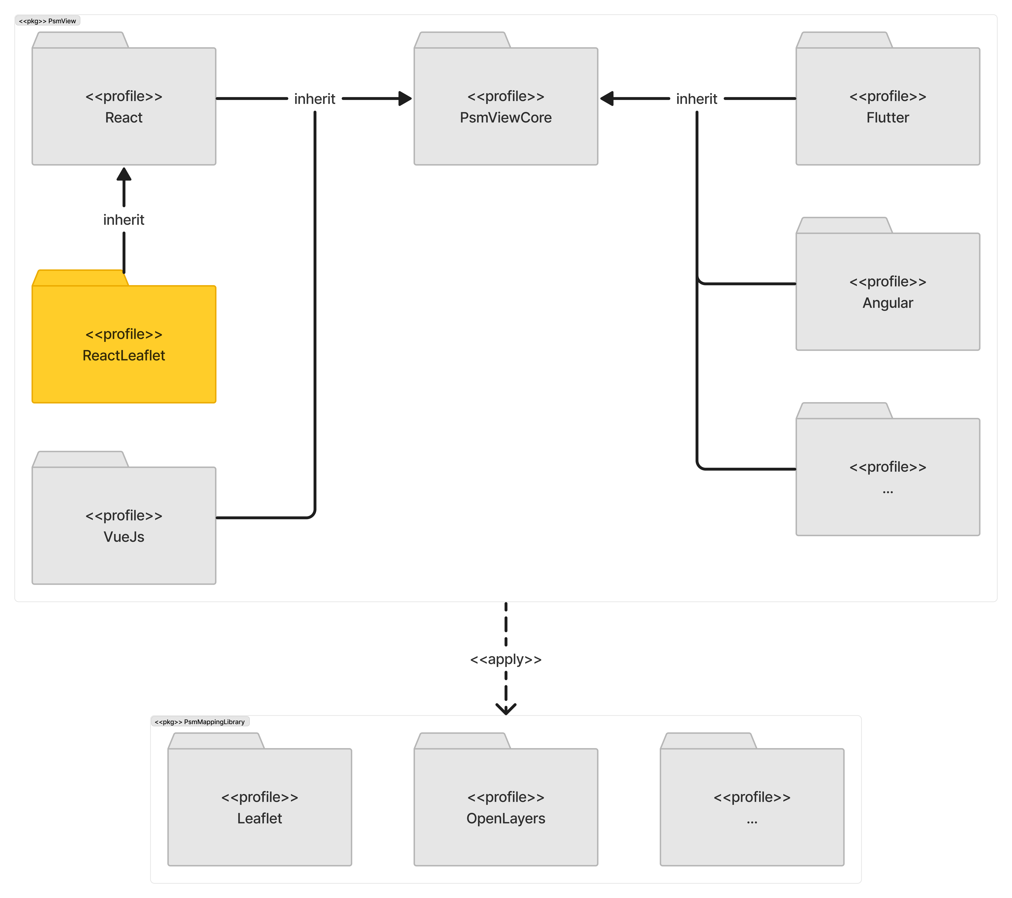

Opening paragraph of React Leaflet

* What is this profile.
* The purpose of having this profile.
  + only to conveniently provide parent classes to be inherited from; so it will not cover many platform-dependent classes and elements
* The brief introduction of what is inside this profile.

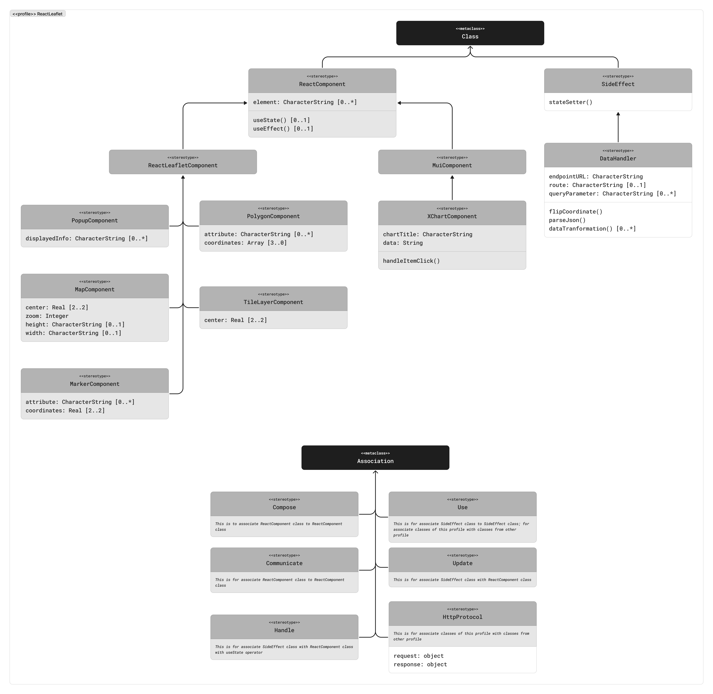

Overview explanation.

* What is inside this profile.
  + Classes
  + Associations
* The reason why

Explanation – …

* What is it.
  + Definition
  + The reason why it is like that.
* The reason is it present here.
* The reason why it inherits a certain parent class if any
* Attributes
  + The reason why it is like that.
* Operations
  + The reason why it is like that.

#### PSM MVC-Controller Package

*Only exclusively talk about why the profile being made like this; not how to use it. For that part, there will be a separate section about it.*

*Everything in “Core” package is only to conveniently provide parent classes to be inherited from; so it will not cover many platform-dependent classes and elements.*

Opening paragraph of PSM MVC-Controller package

* What is this package.
* The purpose of having this package
* The brief introduction of what is inside this package.

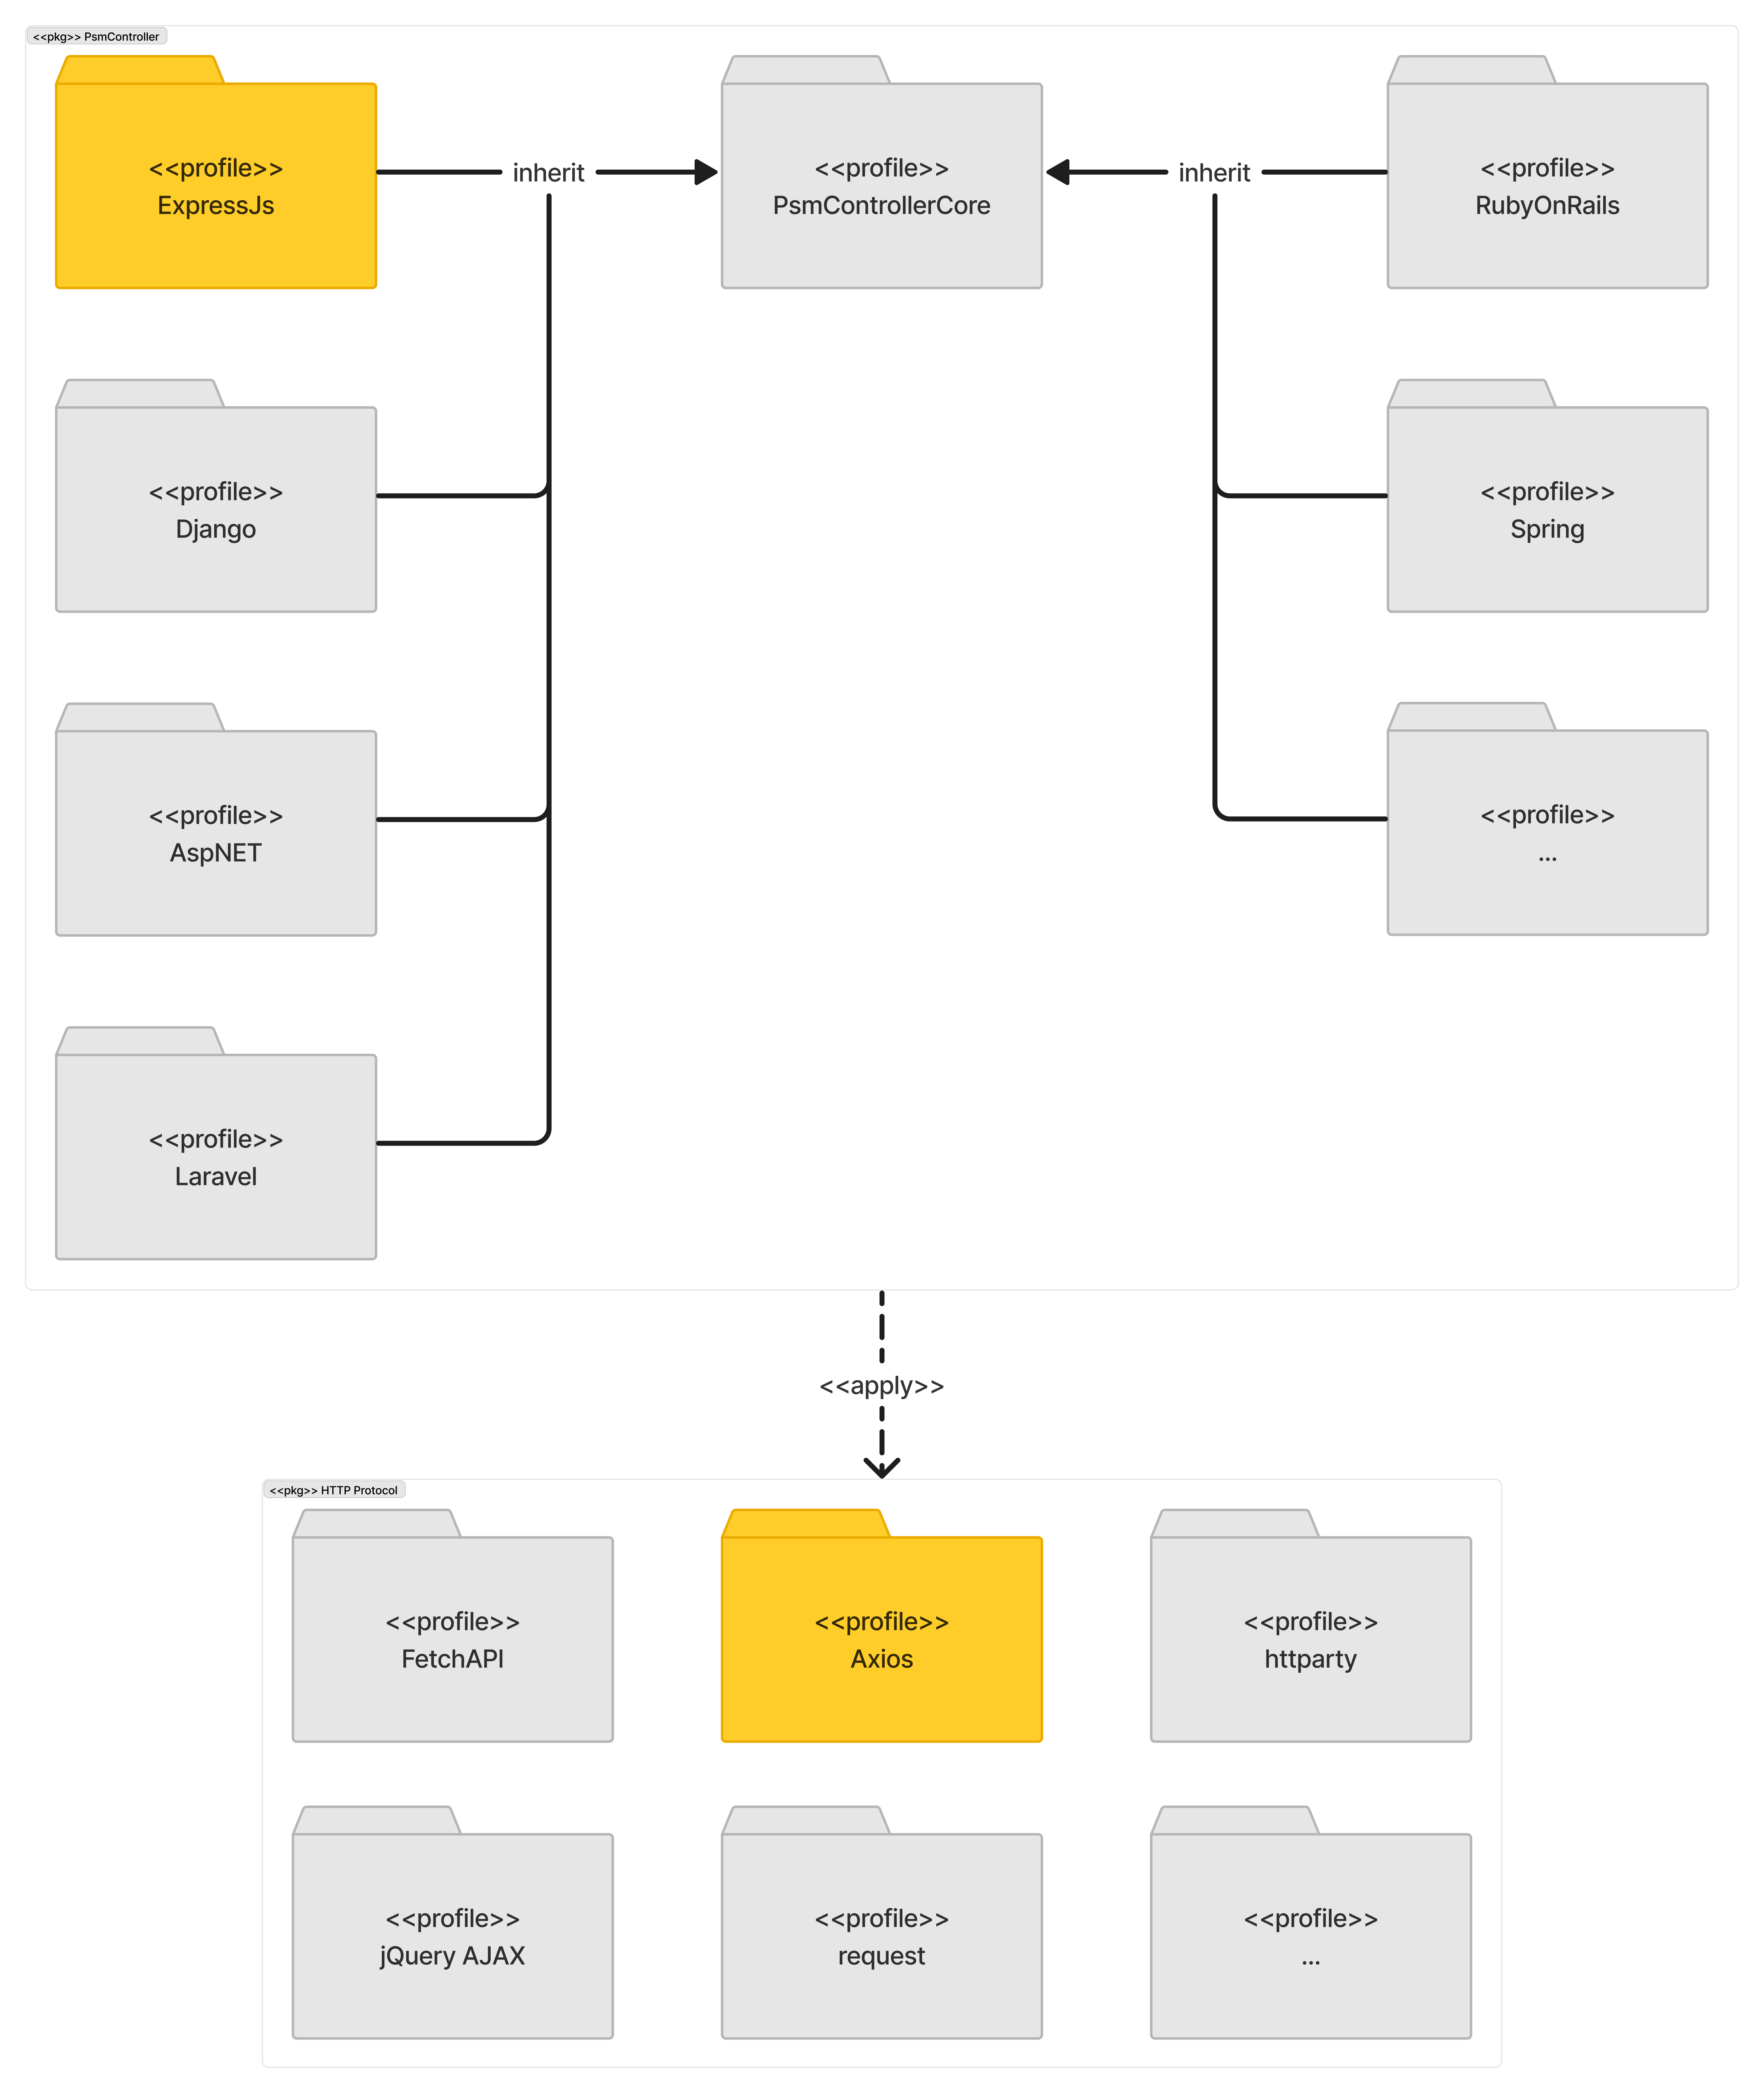

Opening paragraph of Express.js

* What is this profile.
* The purpose of having this profile.
  + only to conveniently provide parent classes to be inherited from; so it will not cover many platform-dependent classes and elements
* The brief introduction of what is inside this profile.

Overview explanation.

* What is inside this profile.
  + Classes
  + Associations
* The reason why

Explanation – …

* What is it.
  + Definition
  + The reason why it is like that.
* The reason is it present here.
* The reason why it inherits a certain parent class if any
* Attributes
  + The reason why it is like that.
* Operations
  + The reason why it is like that.

Opening paragraph of Axios

* What is this profile.
* The purpose of having this profile.
  + only to conveniently provide parent classes to be inherited from; so it will not cover many platform-dependent classes and elements
* The brief introduction of what is inside this profile.

Overview explanation.

* What is inside this profile.
  + Classes
  + Associations
* The reason why

Explanation – …

* What is it.
  + Definition
  + The reason why it is like that.
* The reason is it present here.
* The reason why it inherits a certain parent class if any
* Attributes
  + The reason why it is like that.
* Operations
  + The reason why it is like that.

## MDA Demonstration (not yet structured)

Opening paragraph of MDA demonstration

* User target: designer, developer
  + The reason why those users
  + What the users do by knowing this step
* What the step is doing
* What the purpose
* Expected final result

### PIM Instantiation (not yet structured)

Opening paragraph of PIM instantiation

* What the step is doing
  + Developing a PIM of web
* What the purpose
* Briefly introduce potential use of this to all targeted users
  + Which will be detailed in later demonstration section

### PIM to PSM Transformation Development (not yet structured)

Opening paragraph of PIM to PSM transformation development

* What the step is doing
  + Transformation from PIM to PSM using model transformation
  + In this phase, PIM instantiation is assumed to be created
* What the purpose
* Briefly introduce potential use of this to all targeted users
  + Which will be detailed in later demonstration section

Transformation rules

1. …
2. When a PIM stereotype of any MVC pattern is being chosen, user is to compile all available PSM profiles that is “fall within the category of” the chosen stereotype of the same MVC pattern.
   1. Example: when choosing “Local Database” …
   2. Currently depends on user’s discretion and judgement.
   3. Recommendation: this can be automated later.
   4. Later in the draft: I need to demonstrate in my choice

* … *more* *will be discovered during demonstration …*

### XXXXXXXXXXX

# Discussion and Recommendation

## Title section

This is Body Text style. Use this for the body text.

### Title sub-section

This is Body Text style. Use this for the body text.

List of references

Ameller, D., Burgués, X., Collell, O., Costal, D., Franch, X., & Papazoglou, M. P. (2015). Development of service-oriented architectures using model-driven development: A mapping study. *Information and Software Technology*, *62*(1), 42–66. https://doi.org/10.1016/J.INFSOF.2015.02.006

Betari, O., Filali, S., Azzaoui, A., & Boubnad, M. A. (2018). Applying a Model Driven Architecture Approach: Transforming CIM to PIM Using UML. *International Journal of Online and Biomedical Engineering (IJOE)*, *14*(09), 170–181. https://doi.org/10.3991/IJOE.V14I09.9137

Blanc, N., Cannata, M., Collombin, M., Ertz, O., Giuliani, G., & Ingensand, J. (2022). OGC API State of Play - A Practical Testbed for The National Spatial Data Infrastructure in Switzerland. *International Archives of the Photogrammetry, Remote Sensing and Spatial Information Sciences - ISPRS Archives*, *48*(4/W1-2022), 59–65. https://doi.org/10.5194/ISPRS-ARCHIVES-XLVIII-4-W1-2022-59-2022

Conallen, J. (1999). *Building Web applications with UML*.

Distante, D., Pedone, P., Rossi, G., & Canfora, G. (2007). Model-driven development of Web applications with UWA, MVC and JavaServer faces. *Lecture Notes in Computer Science (Including Subseries Lecture Notes in Artificial Intelligence and Lecture Notes in Bioinformatics)*, *4607 LNCS*, 457–472. https://doi.org/10.1007/978-3-540-73597-7_38/COVER

Duke, D. J., Evans, A. S., Clark, T., Clark, T., & Evans, A. (1997). *Foundations of the Unified Modeling Language*. 14–15. https://doi.org/10.14236/EWIC/FA1997.6

Fielding, R. T., Taylor, R. N., Erenkrantz, J. R., Gorlick, M. M., Whitehead, J., Khare, R., & Oreizy, P. (2017). Reflections on the REST architectural style and “principled design of the modern web architecture” (impact paper award. *Proceedings of the ACM SIGSOFT Symposium on the Foundations of Software Engineering*, *Part F130154*, 4–14. https://doi.org/10.1145/3106237.3121282

Giubergia, A., Riesco, D., Gil-Costa, V., & Printista, M. (2014). UML Profile for Mining Process: Supporting Modeling and Simulation Based on Metamodels of Activity Diagram. *Modelling and Simulation in Engineering*, *2014*(1), 974850. https://doi.org/10.1155/2014/974850

Gómez, A., Rodríguez, R. J., Cambronero, M. E., & Valero, V. (2019). Profiling the publish/subscribe paradigm for automated analysis using colored Petri nets. *Software and Systems Modeling*, *18*(5), 2973–3003. https://doi.org/10.1007/S10270-019-00716-1/FIGURES/21

Gosala, B., Chowdhuri, S. R., Singh, J., Gupta, M., & Mishra, A. (2021). Automatic Classification of UML Class Diagrams Using Deep Learning Technique: Convolutional Neural Network. *Applied Sciences 2021, Vol. 11, Page 4267*, *11*(9), 4267. https://doi.org/10.3390/APP11094267

Hossain, M. I. (2023). Software Development Life Cycle (SDLC) Methodologies for Information Systems Project Management. *IJFMR - International Journal For Multidisciplinary Research*, *5*(5). https://doi.org/10.36948/IJFMR.2023.V05I05.6223

IEEE. (1990). IEEE Standard Glossary of Software Engineering Terminology. *Office*, *121990*(1), 1. https://doi.org/10.1109/IEEESTD.1990.101064

Jiang, S., & Mu, H. (2011). Design patterns in object oriented analysis and design. *ICSESS 2011 - Proceedings: 2011 IEEE 2nd International Conference on Software Engineering and Service Science*, 326–329. https://doi.org/10.1109/ICSESS.2011.5982229

Kamatchi, Iyer, J., & Singh, S. (2013). Software Engineering:Web Development Life Cycle. *International Journal of Engineering Research & Technology*, *2*(3). https://doi.org/10.17577/IJERTV2IS3438

Ma, W.-M., & Chao, W. S. (2020). Structure-Behavior Coalescence Abstract State Machine for Metamodel-Based Language in Model-Driven Engineering. *IEEE Systems Journal*, *15*(3), 4105–4115. https://doi.org/10.1109/JSYST.2020.3027195

Malik, S., & Kim, D. H. (2017). A comparison of RESTful vs. SOAP web services in actuator networks. *International Conference on Ubiquitous and Future Networks, ICUFN*, 753–755. https://doi.org/10.1109/ICUFN.2017.7993893

OGC. (n.d.-a). *OGC API*. Retrieved June 6, 2024, from https://ogcapi.ogc.org/

OGC. (n.d.-b). *OGC API - Common - Part 1: Core*. Retrieved November 19, 2023, from https://docs.ogc.org/is/19-072/19-072.html

OGC. (n.d.-c). *OGC API - Environmental Data Retrieval Standard*. Retrieved June 6, 2024, from https://docs.ogc.org/is/19-086r6/19-086r6.html

OGC. (n.d.-d). *OGC API - Features - Part 1: Core corrigendum*. Retrieved June 6, 2024, from https://docs.ogc.org/is/17-069r4/17-069r4.html

OGC. (n.d.-e). *OGC API - Maps - Part 1: Core*. Retrieved June 6, 2024, from https://docs.ogc.org/DRAFTS/20-058.html

OGC. (n.d.-f). *OGC API - Processes - Part 1: Core*. Retrieved June 6, 2024, from https://docs.ogc.org/is/18-062r2/18-062r2.html

OGC. (n.d.-g). *OGC API - Records - Part 1: Core*. Retrieved June 6, 2024, from https://docs.ogc.org/DRAFTS/20-004.html

OGC. (n.d.-h). *OGC API - Tiles - Part 1: Core*. Retrieved June 6, 2024, from https://docs.ogc.org/is/20-057/20-057.html

OMG. (2014). MDA Guide rev 2.0. In *OMG Document ormsc/2014-06-01*. https://www.omg.org/cgi-bin/doc?ormsc/14-06-01

OMG. (2017). *OMG®  Unified Modeling Language®  (OMG UML® )*. https://www.omg.org/spec/UML/20161101/PrimitiveTypes.xmi

Peña-Ortiz, R., Gil, J. A., Sahuquillo, J., & Pont, A. (2013). Analyzing web server performance under dynamic user workloads. *Computer Communications*, *36*(4), 386–395. https://doi.org/10.1016/J.COMCOM.2012.11.005

Pop, D. P., & Altar, A. (2014). Designing an MVC Model for Rapid Web Application Development. *Procedia Engineering*, *69*, 1172–1179. https://doi.org/10.1016/J.PROENG.2014.03.106

Rauf, I., Ruokonen, A., Systa, T., & Porres, I. (2010). Modeling a composite RESTful web service with UML. *ACM International Conference Proceeding Series*, 253–260. https://doi.org/10.1145/1842752.1842801

Rivero, J. M., Grigera, J., Rossi, G., Robles Luna, E., & Koch, N. (2012). Towards Agile Model-Driven Web Engineering. *Lecture Notes in Business Information Processing*, *107 LNBIP*, 142–155. https://doi.org/10.1007/978-3-642-29749-6_10

Rodríguez, C., Baez, M., Daniel, F., Casati, F., Trabucco, J. C., Canali, L., & Percannella, G. (2016). REST APIs: A large-scale analysis of compliance with principles and best practices. *Lecture Notes in Computer Science (Including Subseries Lecture Notes in Artificial Intelligence and Lecture Notes in Bioinformatics)*, *9671*, 21–39. https://doi.org/10.1007/978-3-319-38791-8_2/FIGURES/4

Royce, W. W. (1970). MANAGING THE DEVELOPMENT OF LARGE SOFTWARE SYSTEMS. *Proceedings of the 9th International Conference on Software Engineering*. https://doi.org/10.5555/41765.41801

Selic, B. (2007). A systematic approach to domain-specific language design using UML. *Proceedings - 10th IEEE International Symposium on Object and Component-Oriented Real-Time Distributed Computing, ISORC 2007*, 2–9. https://doi.org/10.1109/ISORC.2007.10

Shcherban, S., Liang, P., Li, Z., & Yang, C. (2021). Multiclass Classification of Four Types of UML Diagrams from Images Using Deep Learning. *Proceedings of the International Conference on Software Engineering and Knowledge Engineering, SEKE*, *2021-July*, 57–62. https://doi.org/10.18293/SEKE2021-185

Singh, Y., & Sood, M. (2010). The Impact of the Computational Independent Model for Enterprise Information System Development. *International Journal of Computer Applications*, *11*(8), 975–8887.

Thomas, D. (2004). MDA: Revenge of the modelers or UML Utopia? *IEEE Software*, *21*(3), 15–17. https://doi.org/10.1109/MS.2004.1293067

Wang, Y. (2016). Semantic information extraction for software requirements using semantic role labeling. *Proceedings of 2015 IEEE International Conference on Progress in Informatics and Computing, PIC 2015*, 332–337. https://doi.org/10.1109/PIC.2015.7489864

Whittle, J., Hutchinson, J., & Rouncefield, M. (2014). The state of practice in model-driven engineering. *IEEE Software*, *31*(3), 79–85. https://doi.org/10.1109/MS.2013.65

Wimmer, M., Schauerhuber, A., Schwinger, W., & Kargl, H. (2006). On the Integration of Web Modeling Languages: Preliminary Results and Future Challenges. *7th International Conference on Web Engineering, Workshop Proceedings*, 255–269. https://repositum.tuwien.at/handle/20.500.12708/51838

Xiao, L., & Greer, D. (2009). Adaptive Agent Model: Software Adaptivity using an Agent-oriented Model-Driven Architecture. *Information and Software Technology*, *51*(1), 109–137. https://doi.org/10.1016/J.INFSOF.2008.02.002